QUOTATION MARKS WITH TERMINAL PUNCTUATION
The 3 types of TERMINAL PUNCTUATION MARKS - period (.), exclamation mark (!), and question marks (?) - go inside the closing quotation marks.
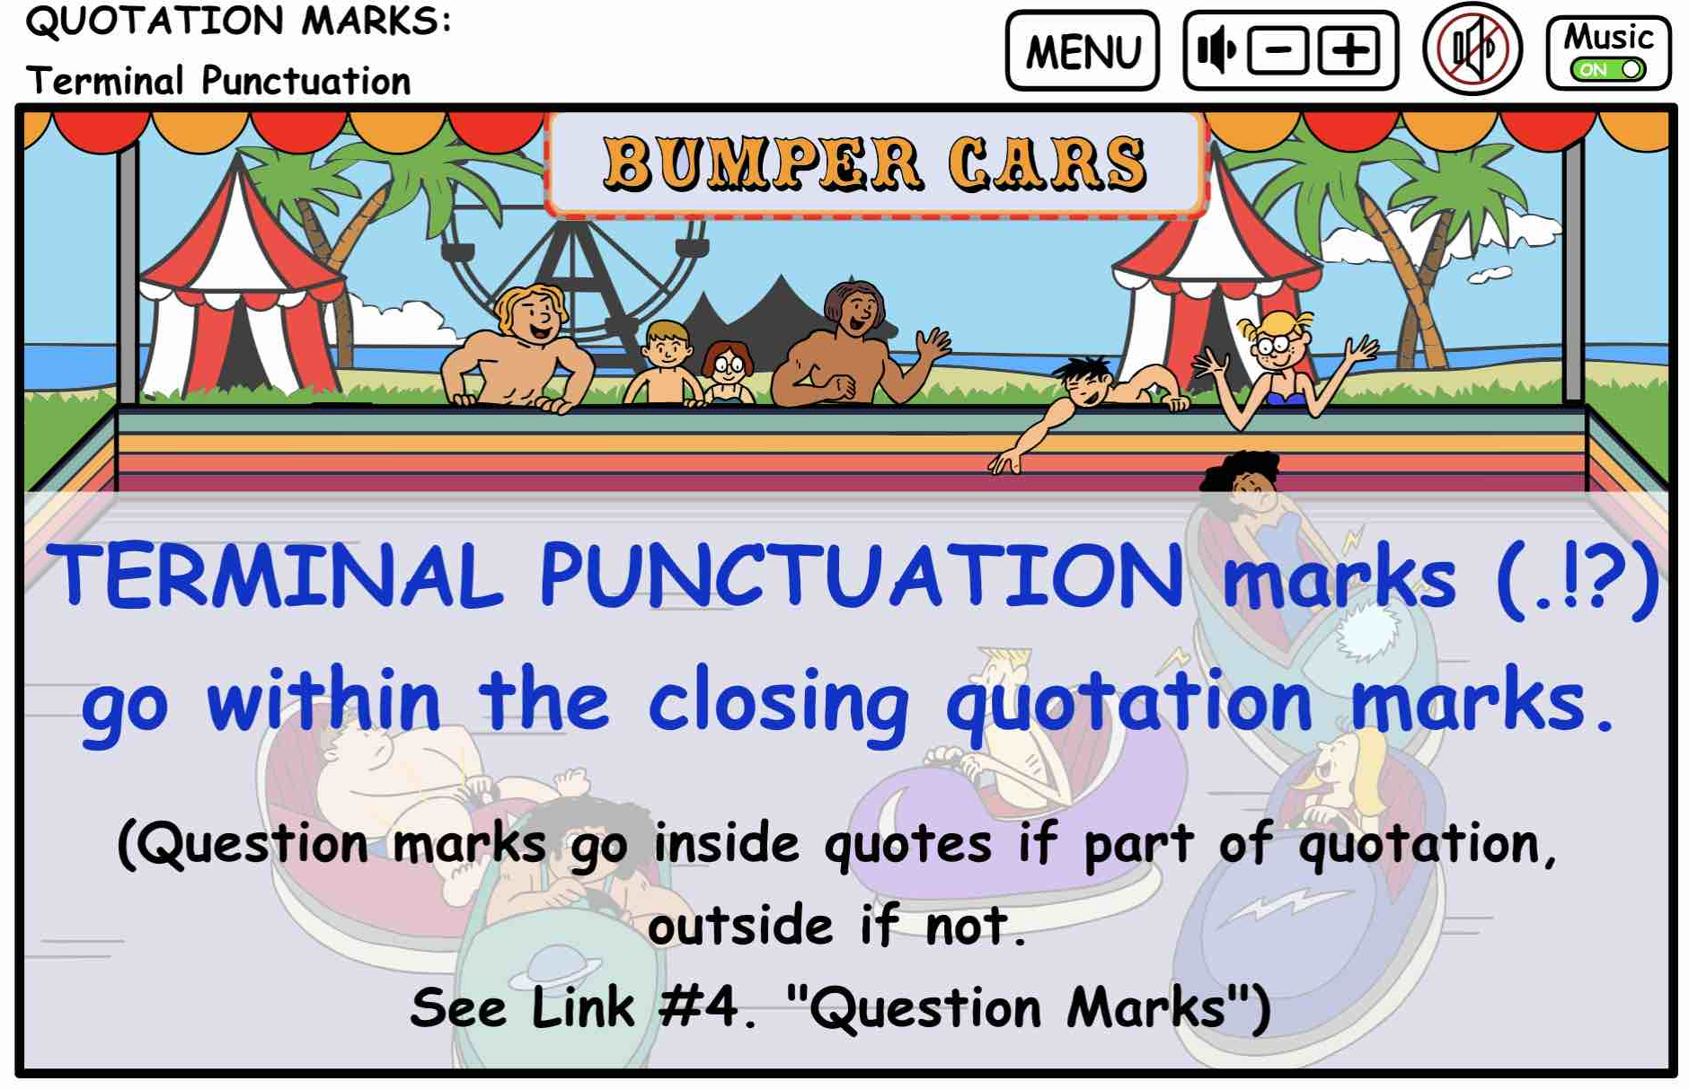
The words that are a direct quotation is
set apart by enclosing it in QUOTATION MARKS.
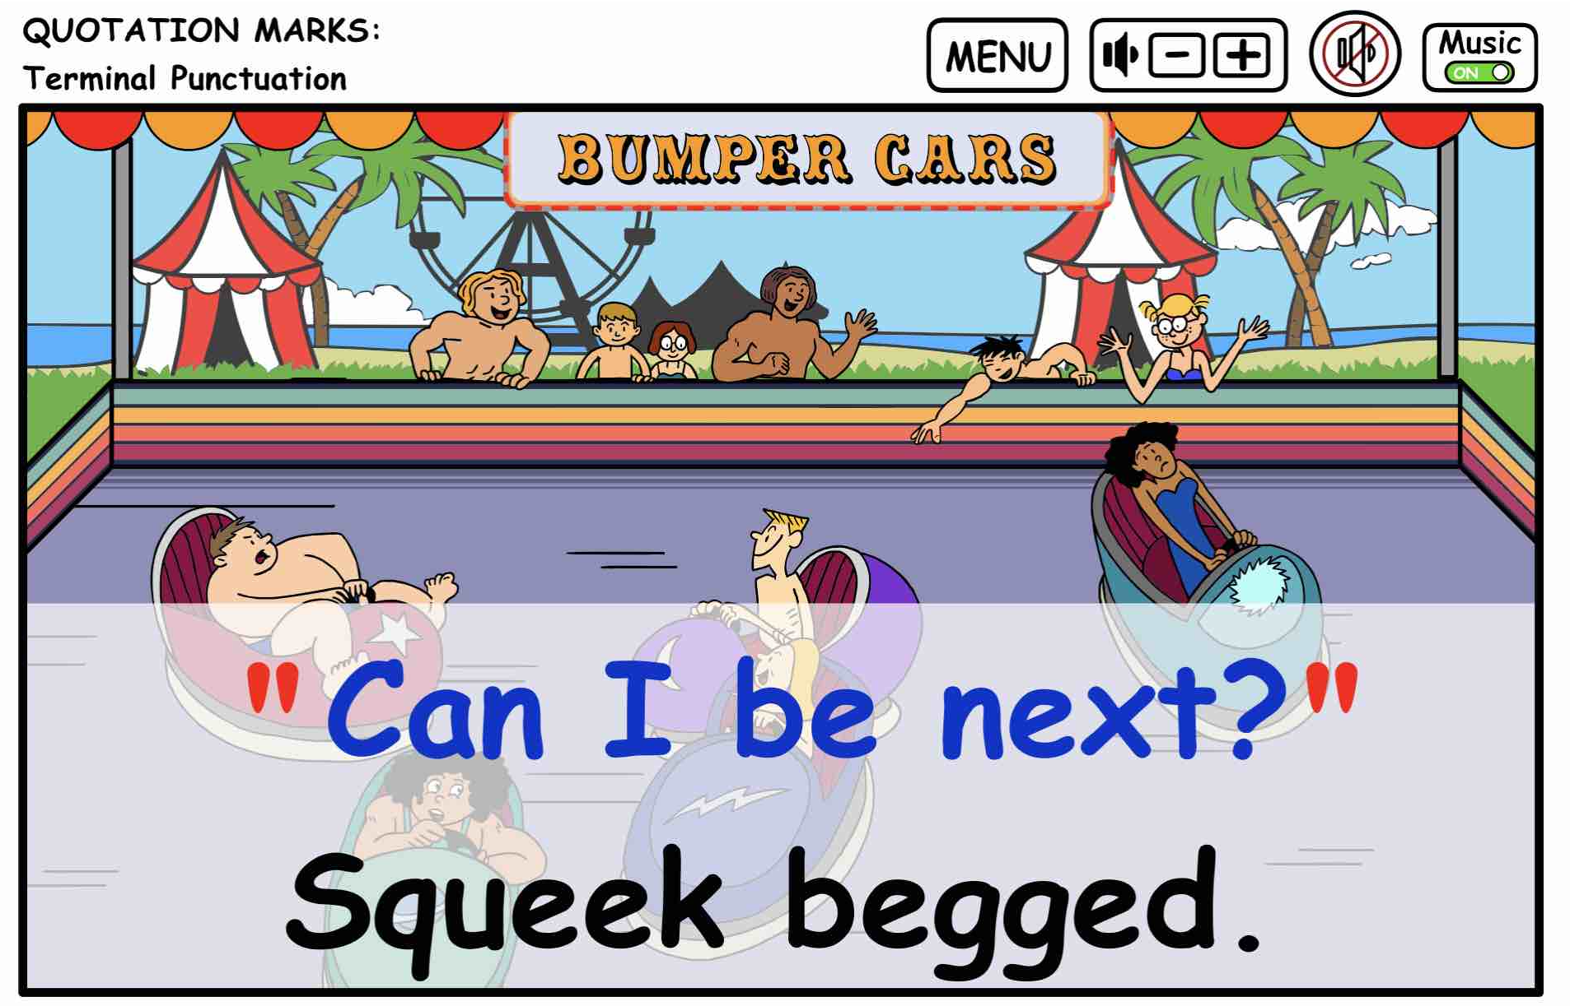
Note: The complete sentence with the name
of the speaker also requires terminal punctuation.
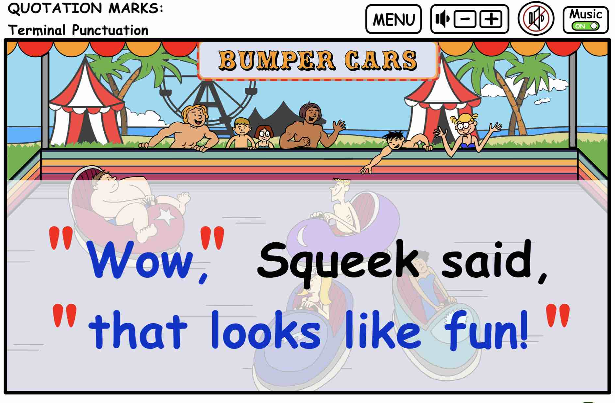
Notice that the speaker’s name splits the sentence in the above example. The first part of the sentence is enclosed in quotation marks. Use a comma to indicate that more of the sentence is coming after the break in the sentence.
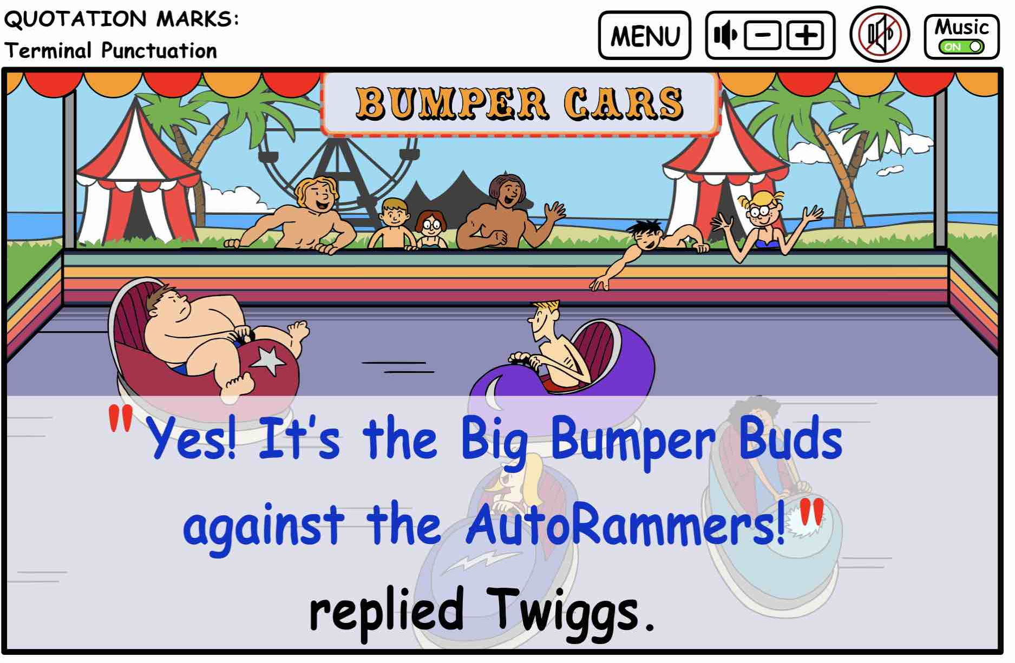
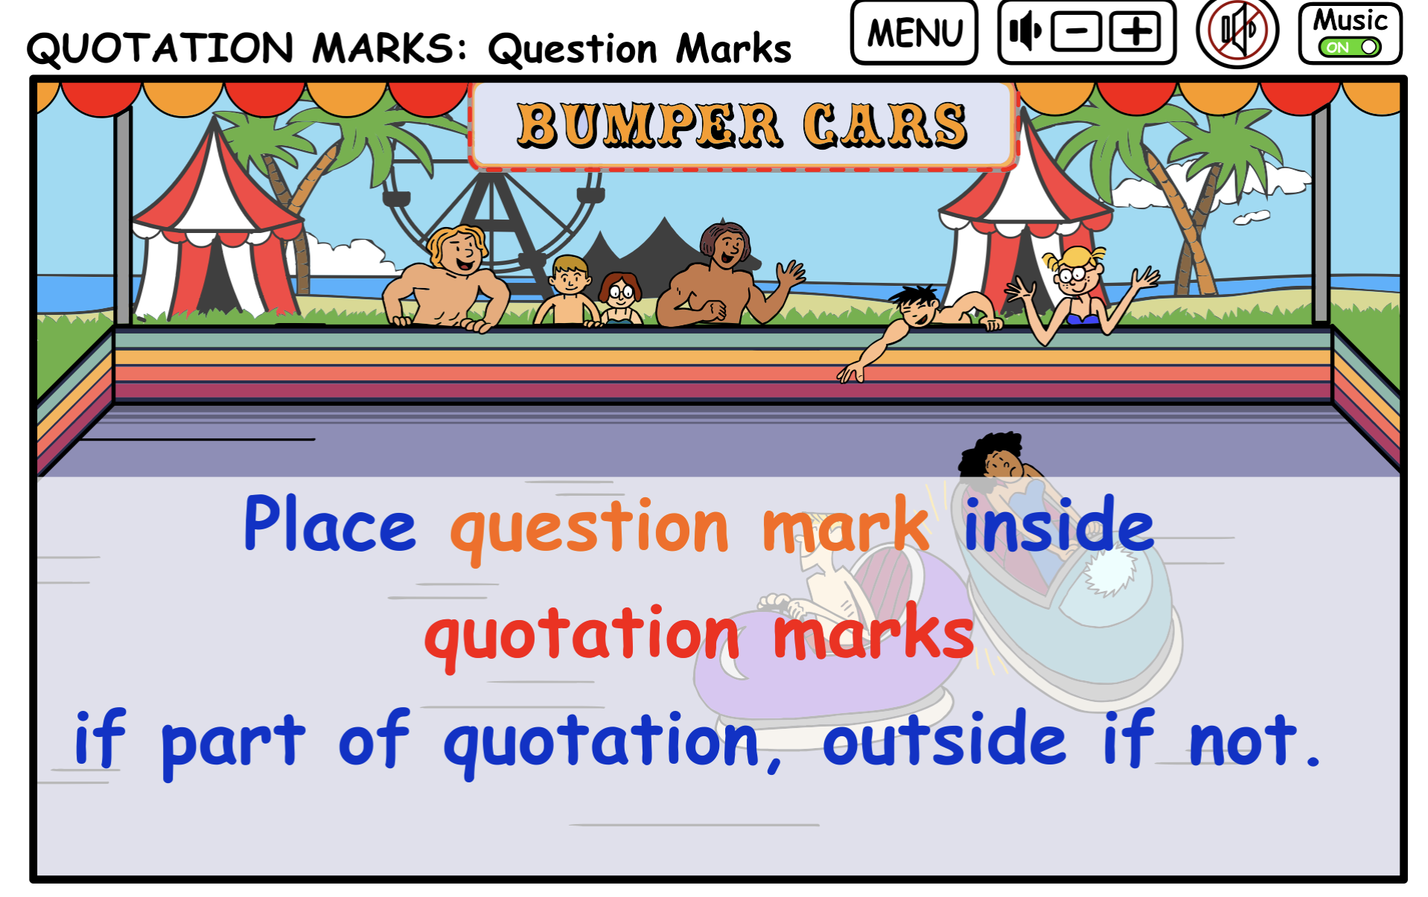

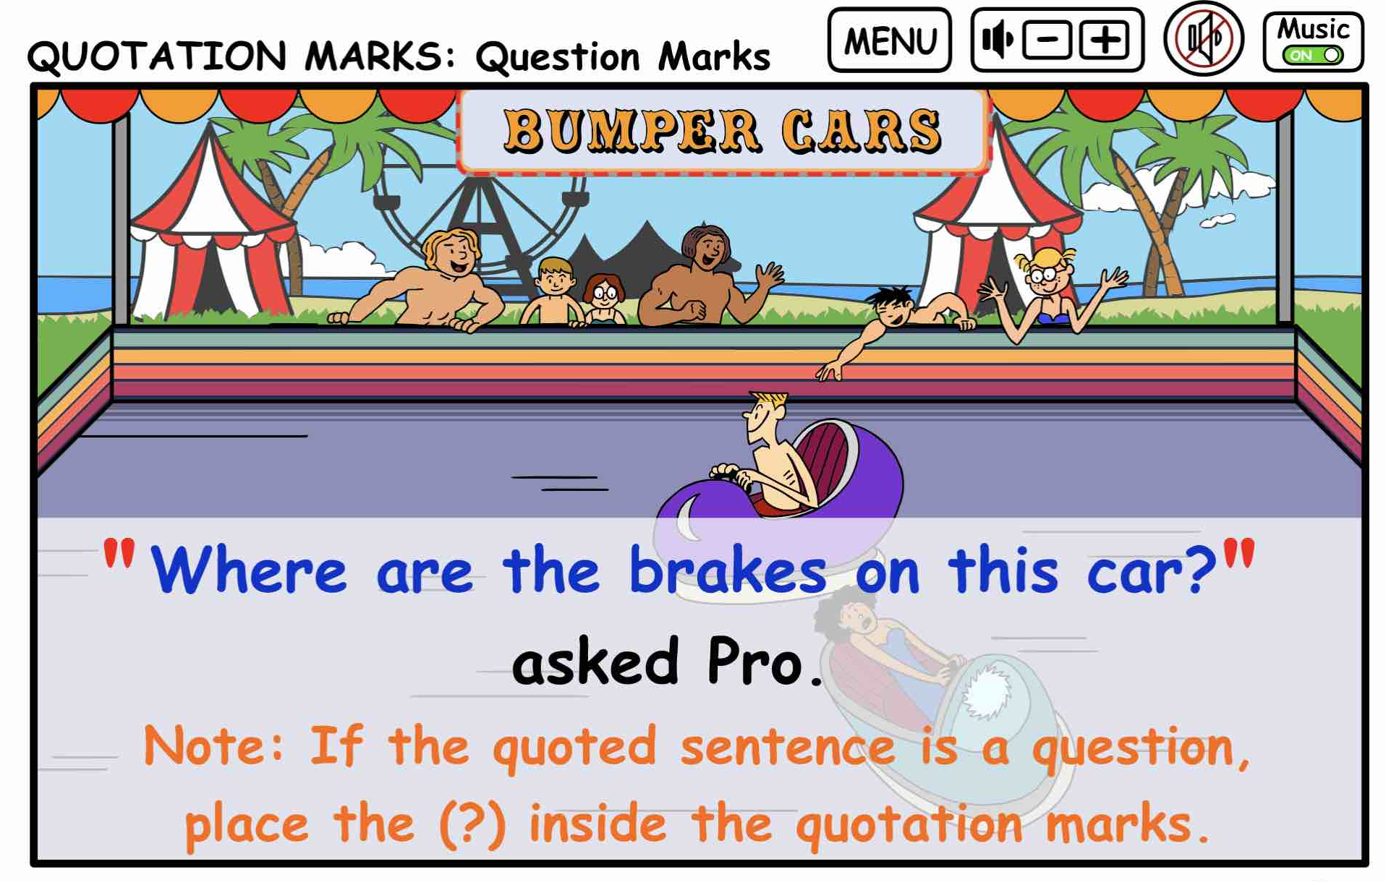
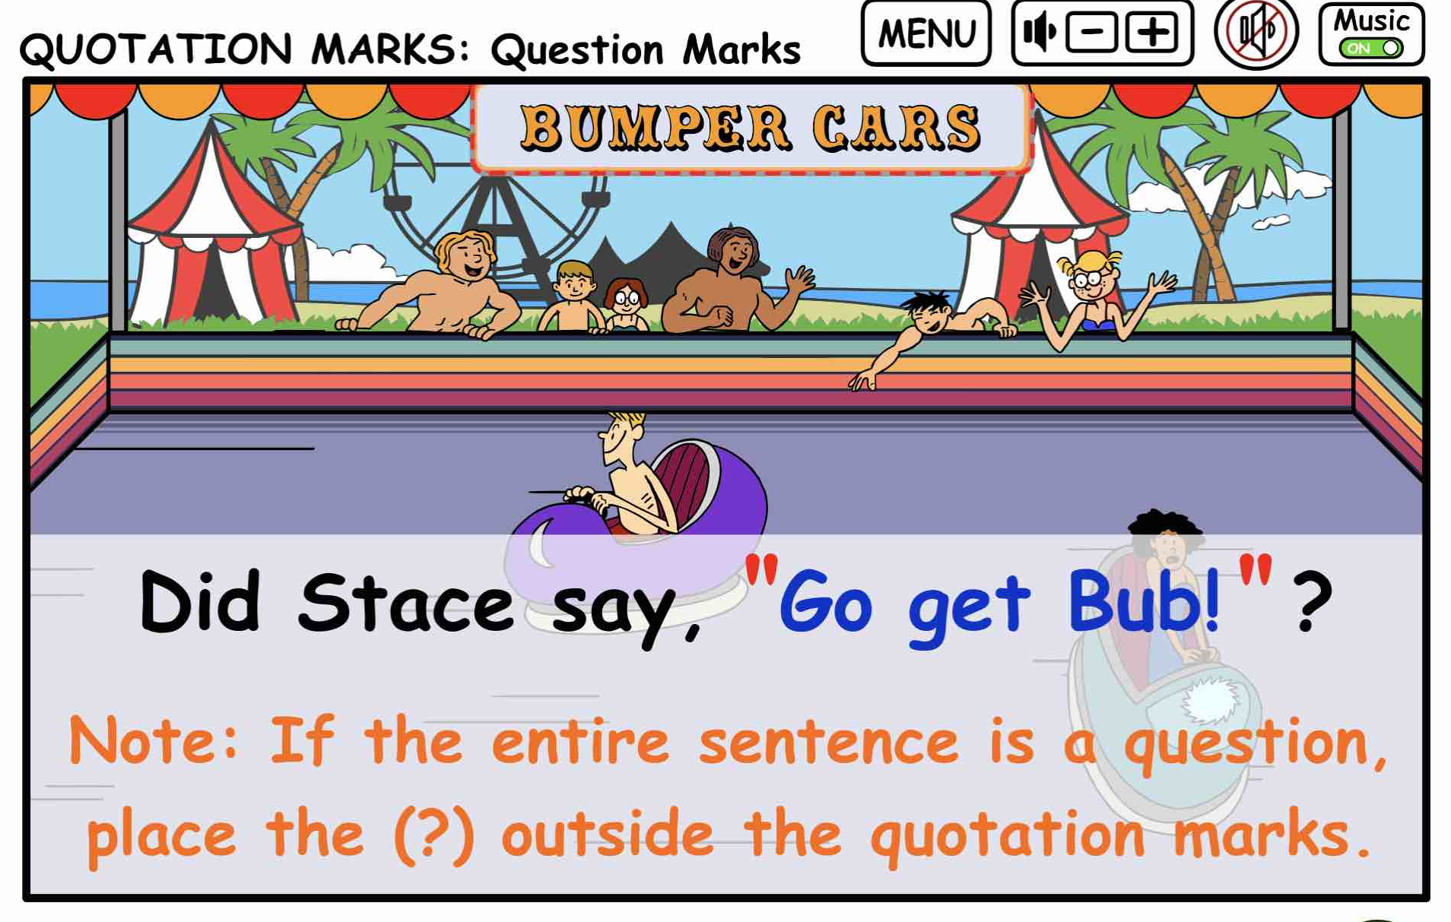
In cases with quotation marks, there are always two complete sentences going on in the main sentence. First you must find the two separate sentences and then figure out what kind of punctuation is needed for each sentence.
When the entire sentence is a question, place the question mark OUTSIDE of the quotation marks.

QUOTATION MARKS PRINTABLE QUIZ:
Punctuate the following sentences using quotation marks and commas.
- Carmen said Let’s go camping this weekend.
- Did anyone check the weather? Barbie asked.
- I can bring the tent. Mick offered.
- Did we all agree when Sam suggested Let’s watch the sunrise together at the crack of dawn.
- Where should we set up camp? Twiggs wondered.
- Slim said The National Beach Reserve is perfect.
- Who’s in charge of the map? Sam asked.
- Stacy reminded them We need extra batteries.
- Did Barbie really say I hope there’s enough space for all of us at the beach park.?
- Can someone bring a first-aid kit? Buffy asked.

Quotation Marks and Commas
ANSWERS as marked below:
- Carmen said, “Let’s go camping this weekend.”
- “Did anyone check the weather?” Barbie asked.
- “I can bring the tent.” Mick offered.
- Did we all agree when Sam suggested, “Let’s watch the sunrise together at the crack of dawn.”?
- “Where should we set up camp?” Twiggs wondered.
- Slim said, “The National Beach Reserve looks perfect.”
- “Who’s in charge of the map?” Sam asked.
- Stacy reminded them, “We need extra batteries.”
- Did Barbie really say, “I hope there’s enough space for all of us at the beach park”?
- “Can someone bring a first-aid kit?” Buffy asked.

