A COMMA SEPARATES A STATEMENT FROM A QUESTION.
When a statement follows a question,
use a comma to separate the two complete clauses.
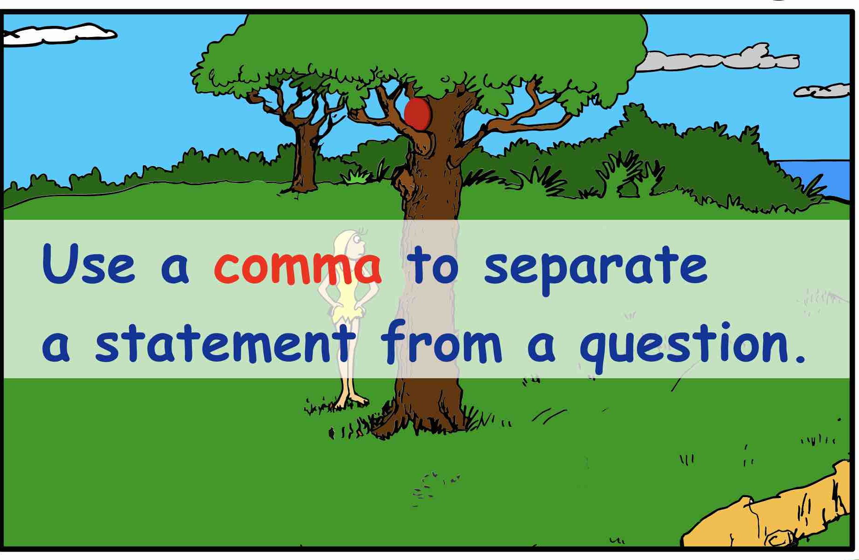
Notice that there are two complete clauses in the sentence below:
- one is a statement (Look at that Frisbee up there …)
- and the other is a question (…is that my Frisbee?)
The two clauses are separated by a comma.
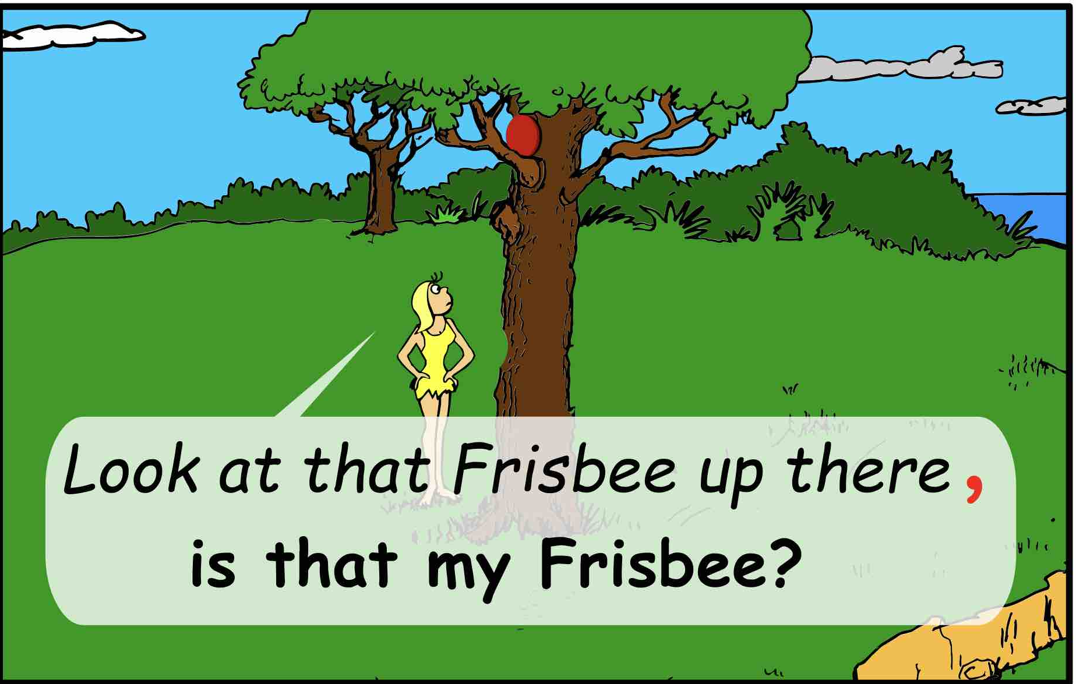
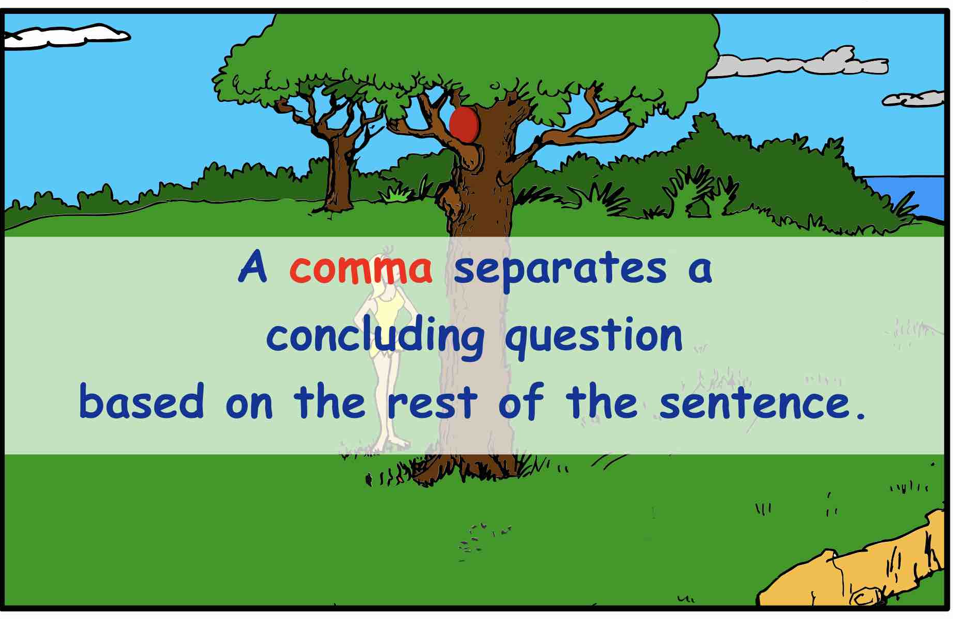
A COMMA SEPARATES A CONCLUDING QUESTION
BASED ON THE REST OF THE SENTENCE.
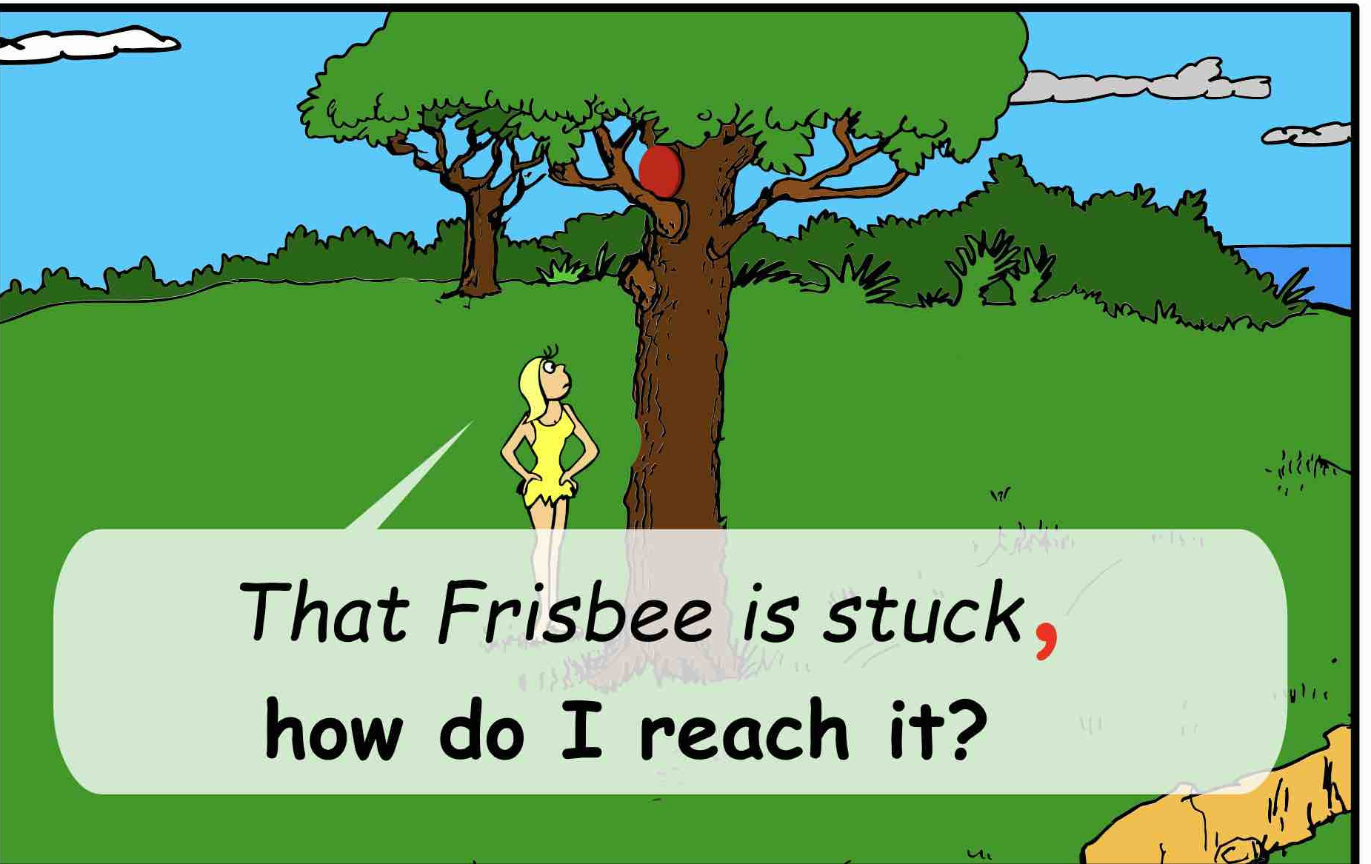
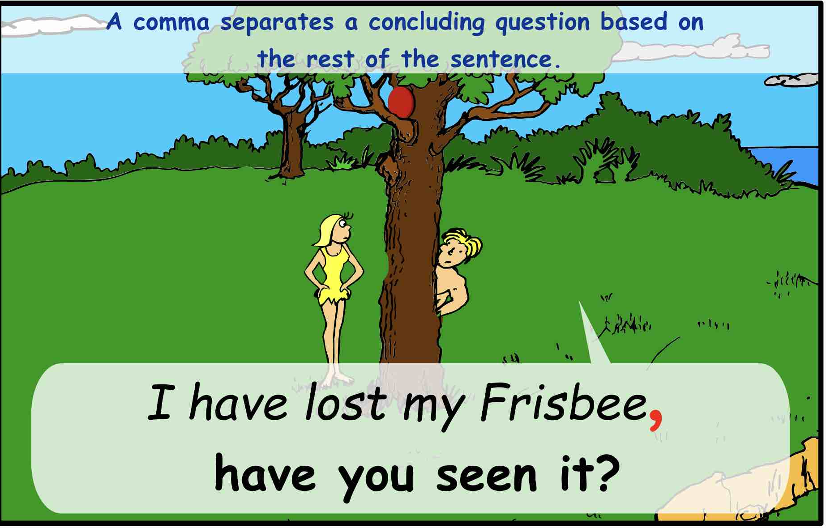
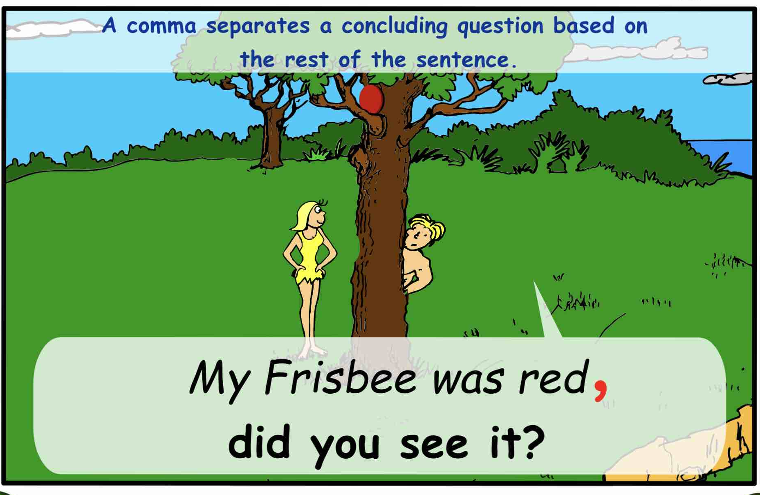
NOTICE: In each of the sample sentences above and below,
there is a statement followed by a question based on the statement.
Those two structures use a comma to separate the two complete clauses.
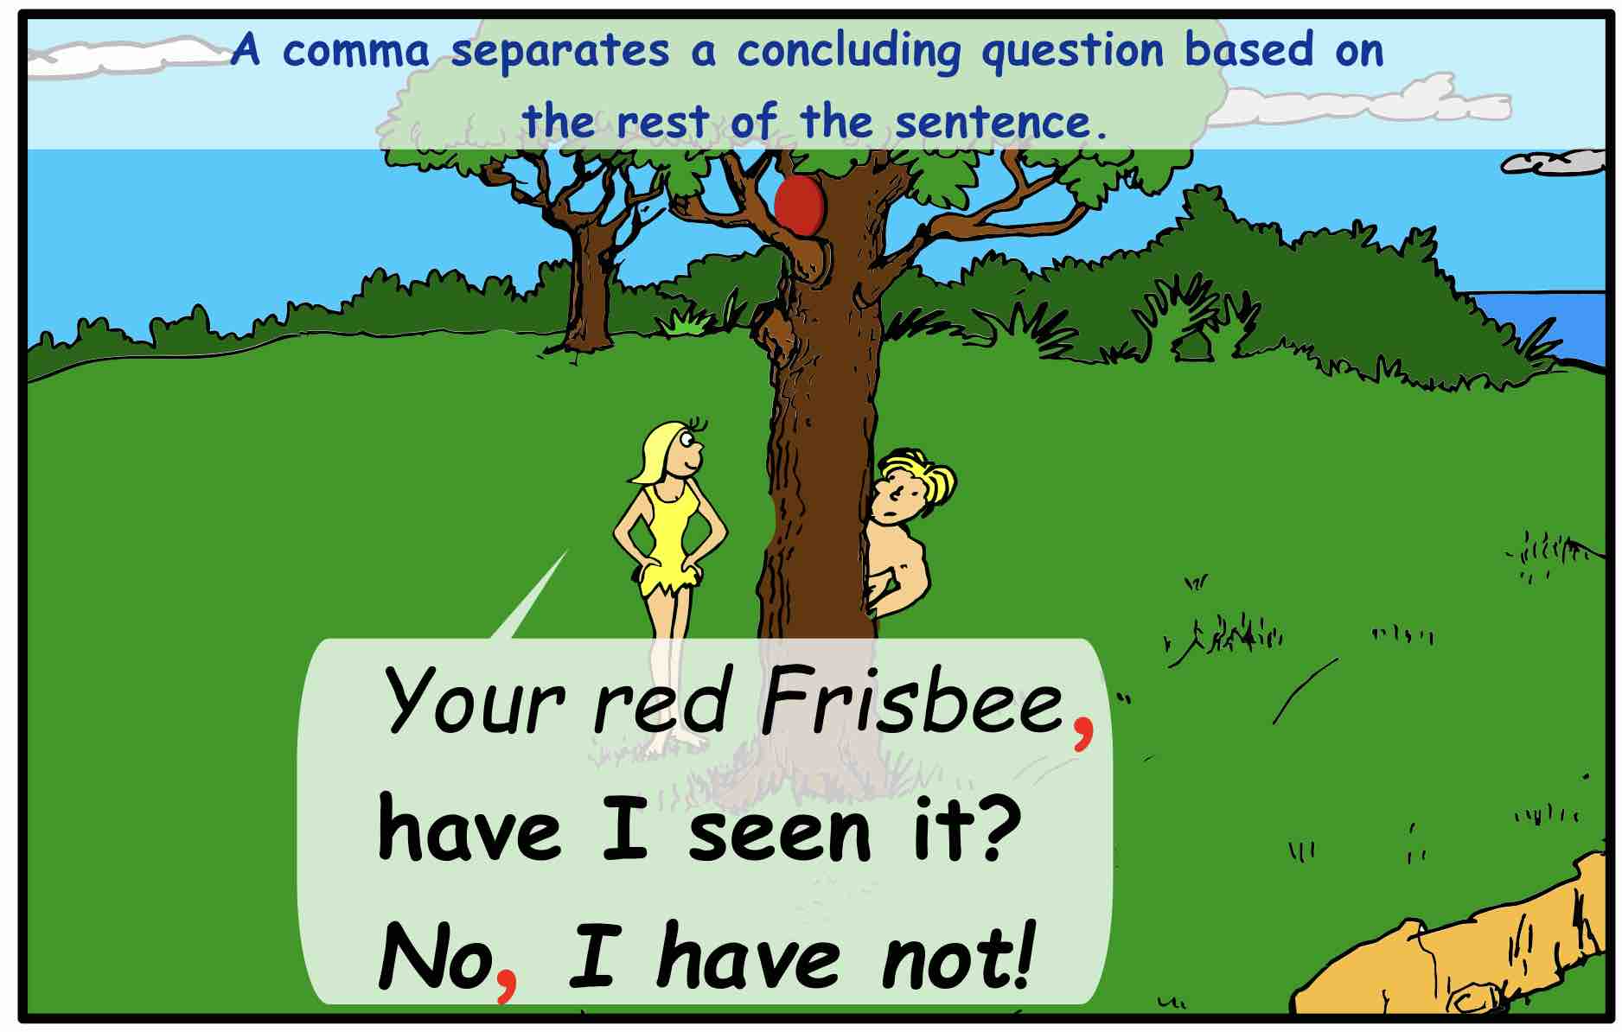
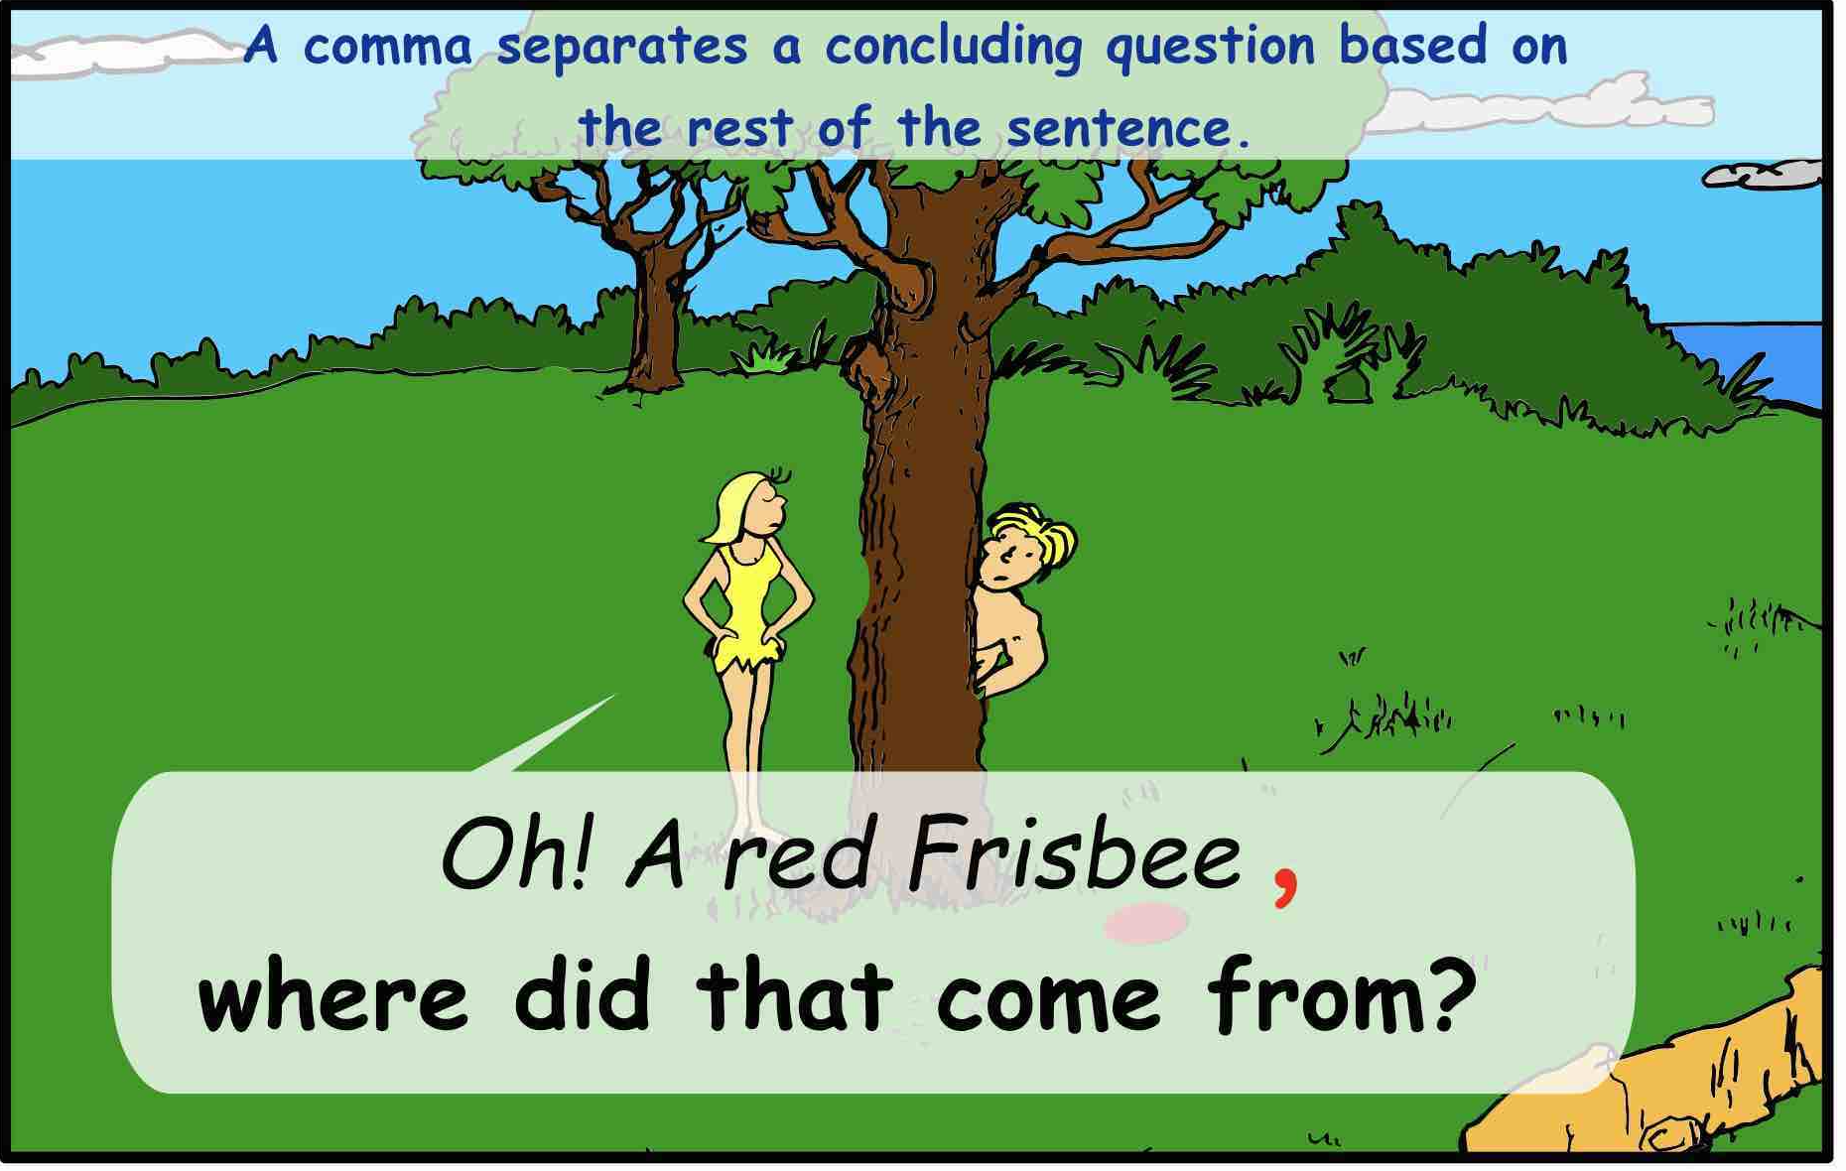

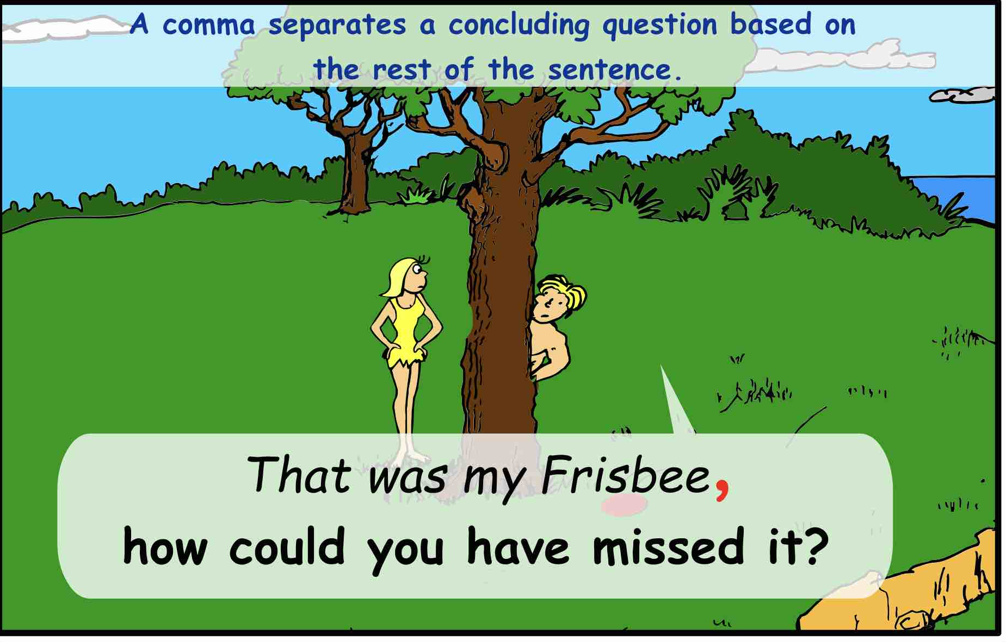

PRINTABLE QUIZ
COMMAS SEPARATE STATEMENT FROM QUESTIONS
DIRECTIONS: PLACE a comma between the statement from question.
- We have reached the edge of the forest but are we really ready for the climb?
- When we follow the narrow trail has anyone notice how steep it is getting?
- I just heard a rustling in the bushes could it be a bear?
- We are at a fork in the path which direction should we go?
- See that distant peak is that our final destination?
- Let’s check the map have we been walking in circles?
- There is the sound of running water growing louder is there a waterfall nearby?
- The trail has become rocky and uneven is anyone struggling make it?
- Look there are footprints in the dirt could it belong to another hiking group perhaps?
- The sky is growing darker overhead is there a storm forming?

COMMAS SEPARATE STATEMENT FROM QUESTIONS
Answers: The answers are indicated below:
- We have reached the edge of the forest, but are we really ready for the climb?
- When we follow the narrow trail, has anyone notice how steep it is getting?
- I just heard a rustling in the bushes, could it be a bear?
- We are at a fork in the path, which direction should we go?
- See that distant peak, is that our final destination?
- Let’s check the map, have we been walking in circles?
- There is the sound of running water growing louder, is there a waterfall nearby?
- The trail has became rocky and uneven, is anyone struggling make it?
- Look there are footprints in the dirt, could it belong to another hiking group perhaps?
- The sky is growing darker overhead, is there a storm forming?

