APPOSITIVES

An APPOSITIVE is a noun or noun form (single noun words, phrases, or clauses) which renames the immediately preceding noun or pronoun. An appositive is usually enclosed by commas and may be written in a series of appositives.

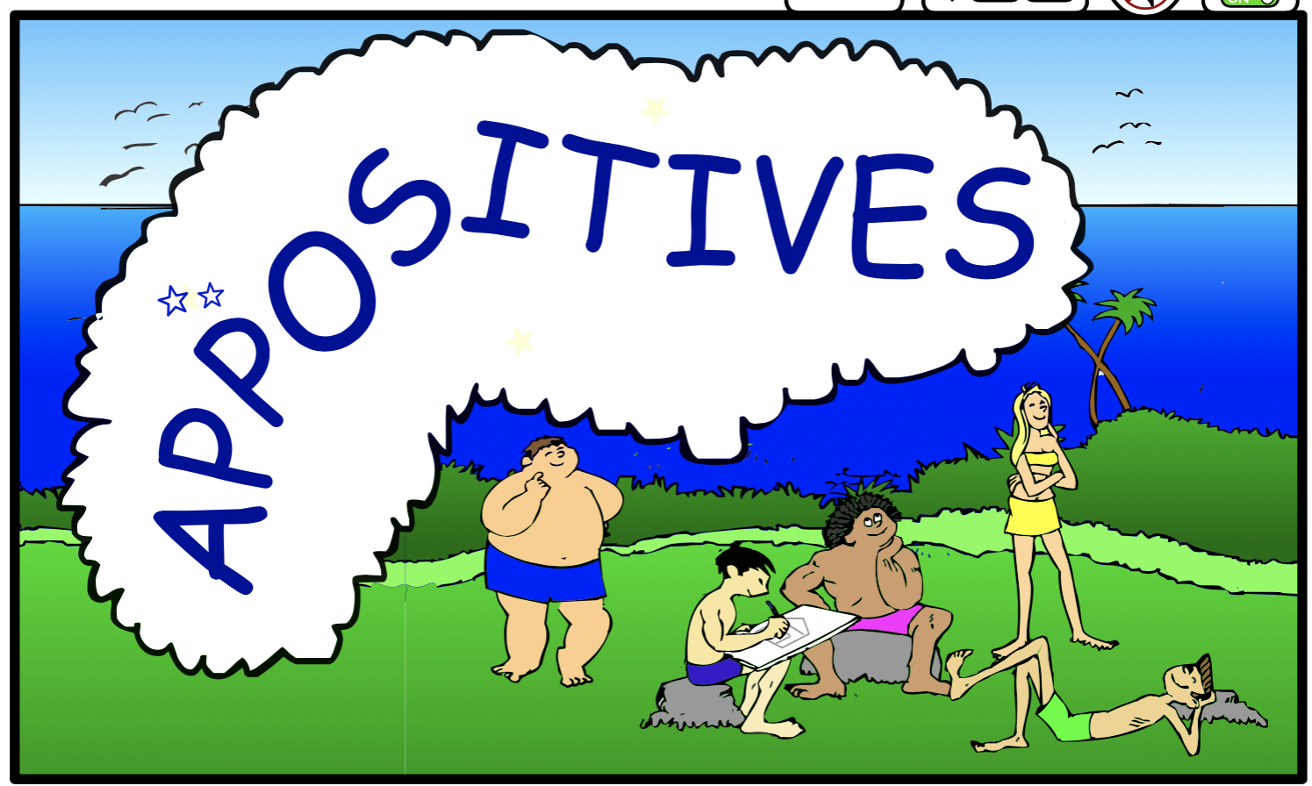
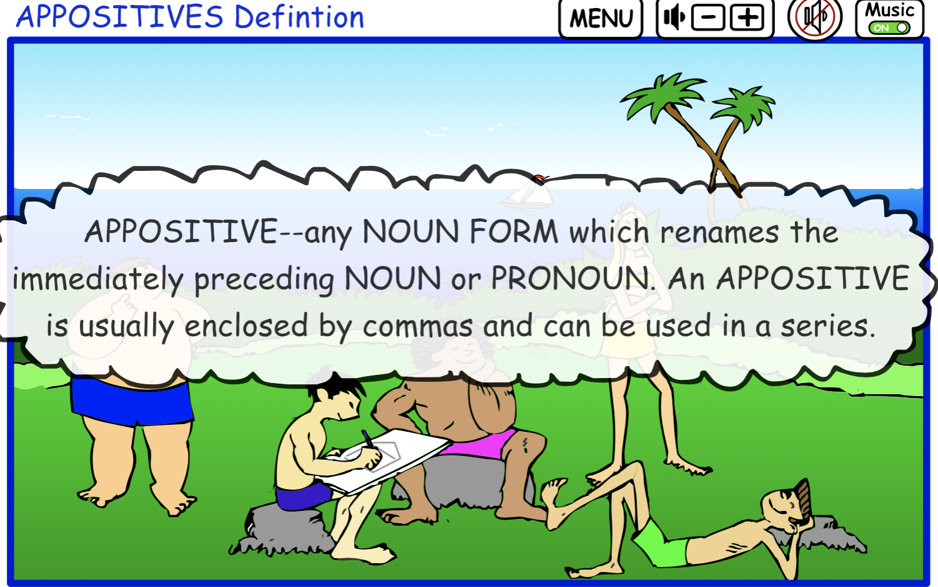

Example:
My friends will arrive next Tuesday, July 4th, Independence Day, my birthday.
July 4th, Independence Day, my birthday – these nouns are all appositives.

Example:
We need some new tools: a wrench, a hammer, and a screwdriver.
A wrench, a hammer, and a screwdriver are all appositives.

Punctuation Note: The COLON introduces a series of appositives occurring naturally at the end of a sentence. If a collective word comes at the beginning of a series, a COLON introduces the following series of items. COMMAS then separate the rest of the appositives.

Here are some of my favorite songs: Beach Bongo, Surfing USA, Save the Best For Last, and Eat My Wake.

Noun forms would be the following:
GERUND PHRASE—a word ending in ING - a present participle (+ complements) (+ modifiers) used as a noun.

NOUN CLAUSE--a sentence structure used as a subject, appositive, object of a preposition, or some type of complement.

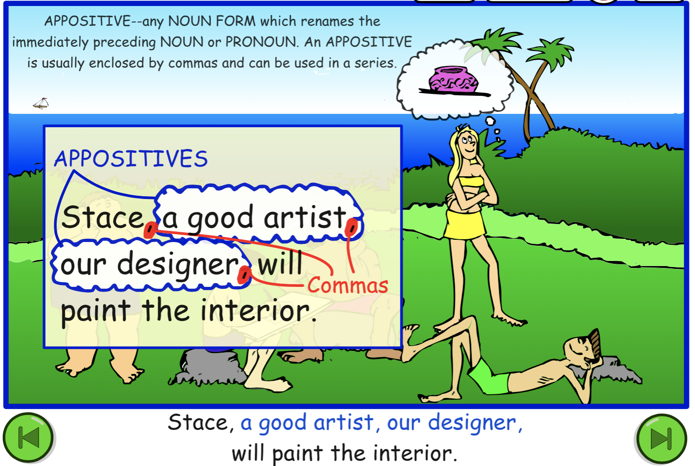
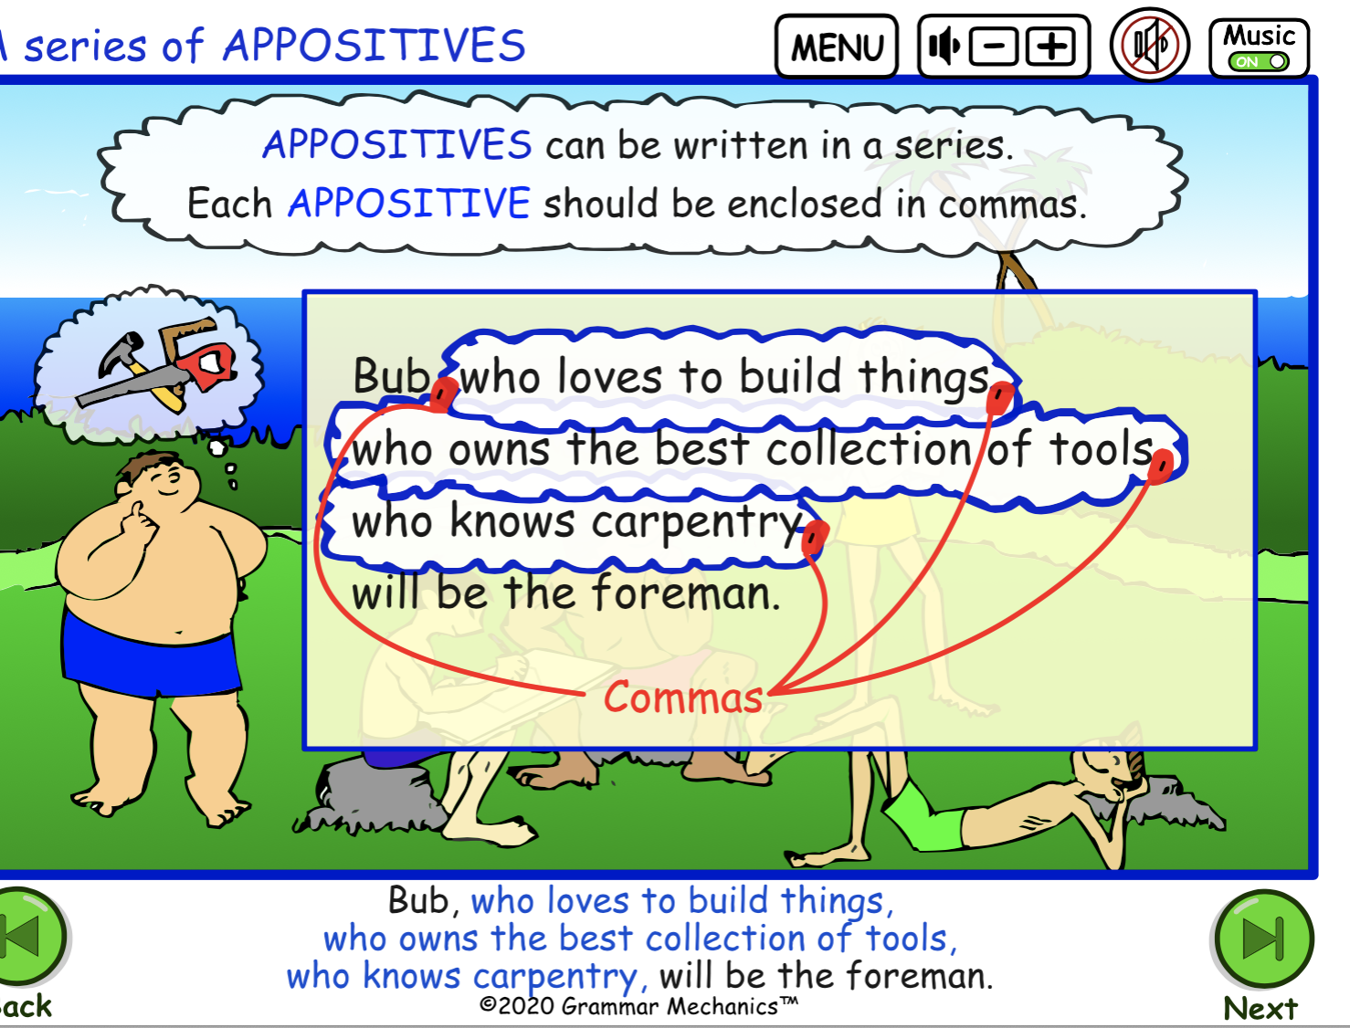
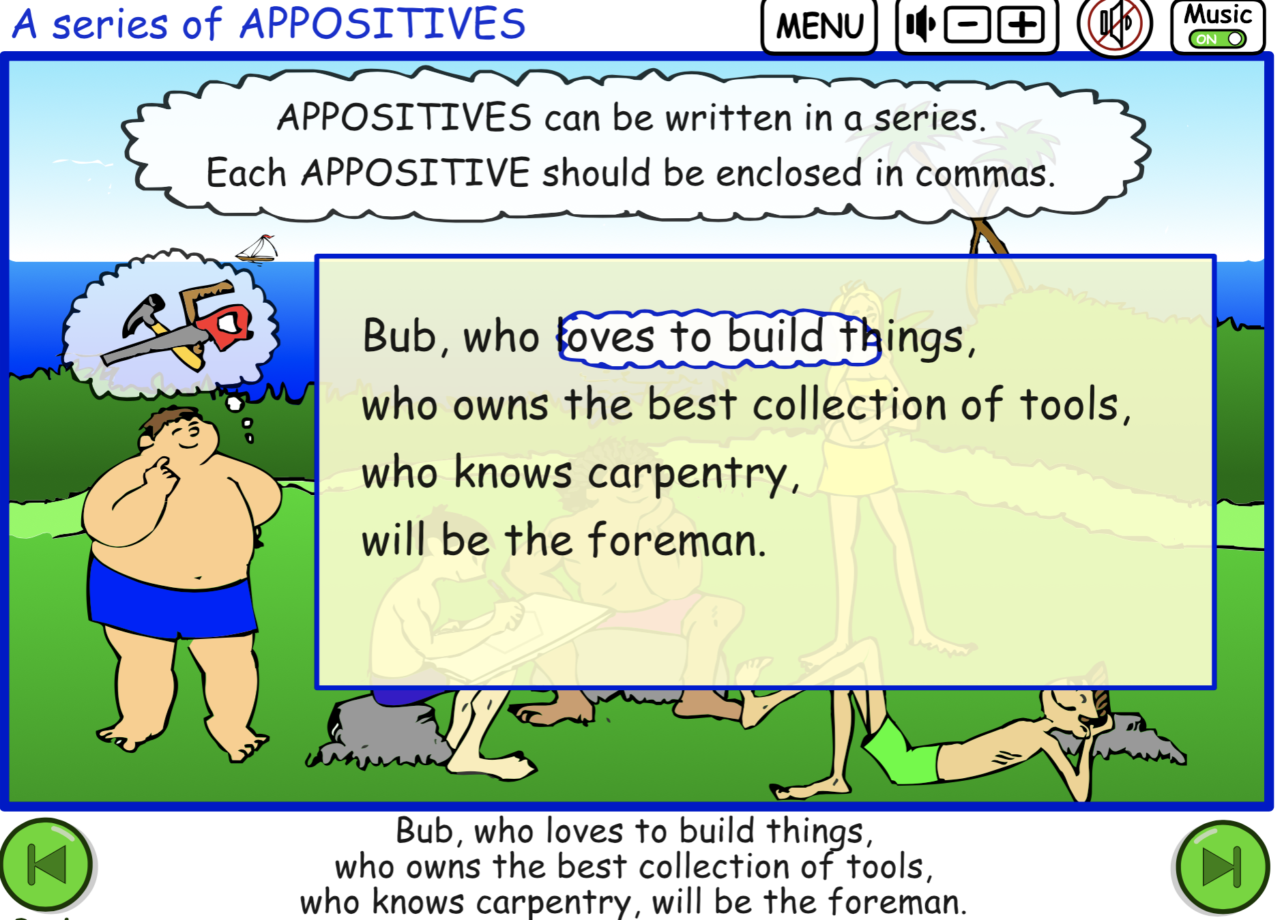

Learn to identify APPOSITIVES; punctuate the following sentences with commas and/or colons:

- Slim keeps singing these songs We Are The Champions,
Don’t Hold Us Down Walk the Talk over and over again.

- Buffy is our best runner head of the team
positive leader and hardest worker in the group.

- These are our training routines running weightlifting stretching warmup jumping jacks and slow cool downs.

- Our athletes the Beach Babes the best surfers in the area train year around for the local tournaments.

Answers: Note if the appositives follow a word that names a collection of things or activities, (songs, routines) a colon comes after that word before the list of the appositives. The appositives are then enclosed in commas.

- Slim keeps singing these songs: We Are The Champions,
Don’t Hold Us Down, Walk the Talk, over and over again.

- Buffy is our best runner, head of the team, positive leader, and hardest worker, in the group.

- These are our training routines: running, weightlifting, stretching, warmup, jumping jacks, and slow cool downs.

- Our athletes, the Beach Babes, the best surfers in the area, train year around for the local tournaments.

