ADJECTIVE CLAUSES are dependent clauses.
They modify nouns or pronouns and begin with words like that, who, whom, whose, and which.

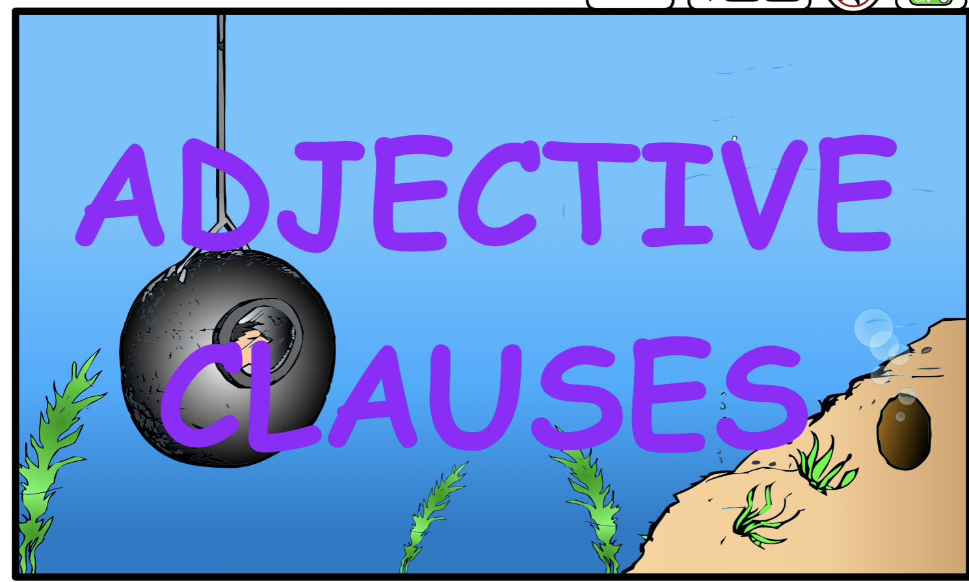
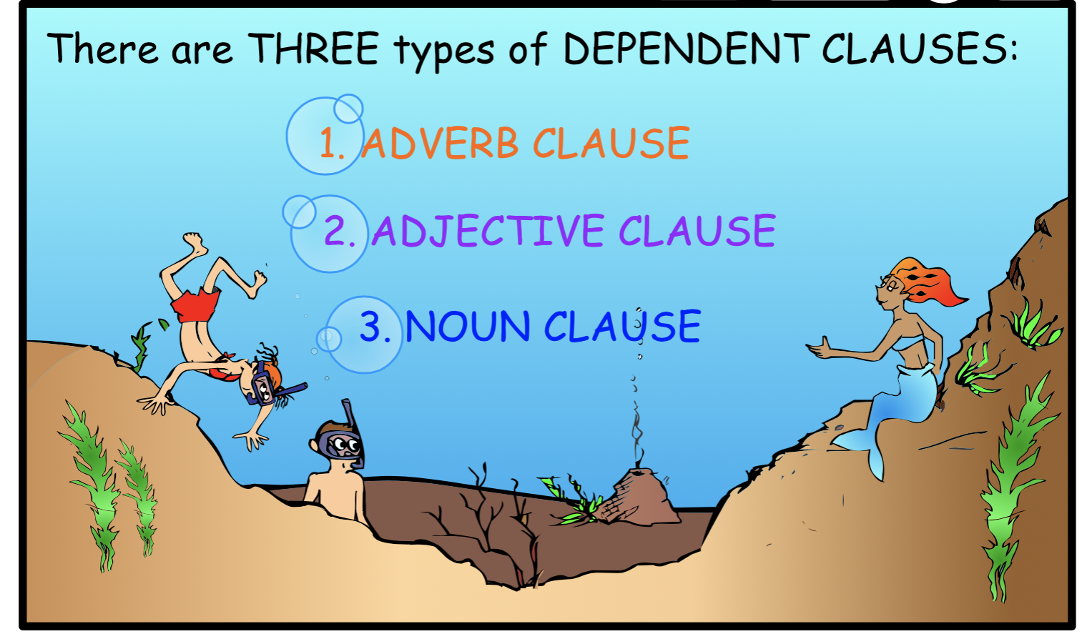
ADJECTIVE CLAUSES are dependent clauses that modify nouns or pronouns.
They answer the 3 questions an ADJECTIVE ANSWERS:
1. Which one?
2. What kind of?
3. How many?
They and begin with words like that, who, whom, whose, and which.

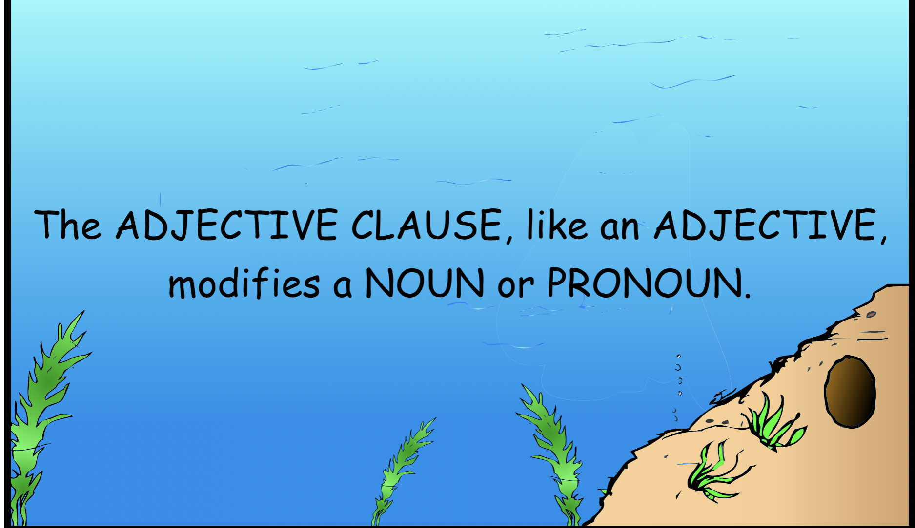
The ADJECTIVE CLAUSE is a clause that answers the same
questions an ADJECTIVE answers:
- Which one? 2. What kind of? 3. How many?
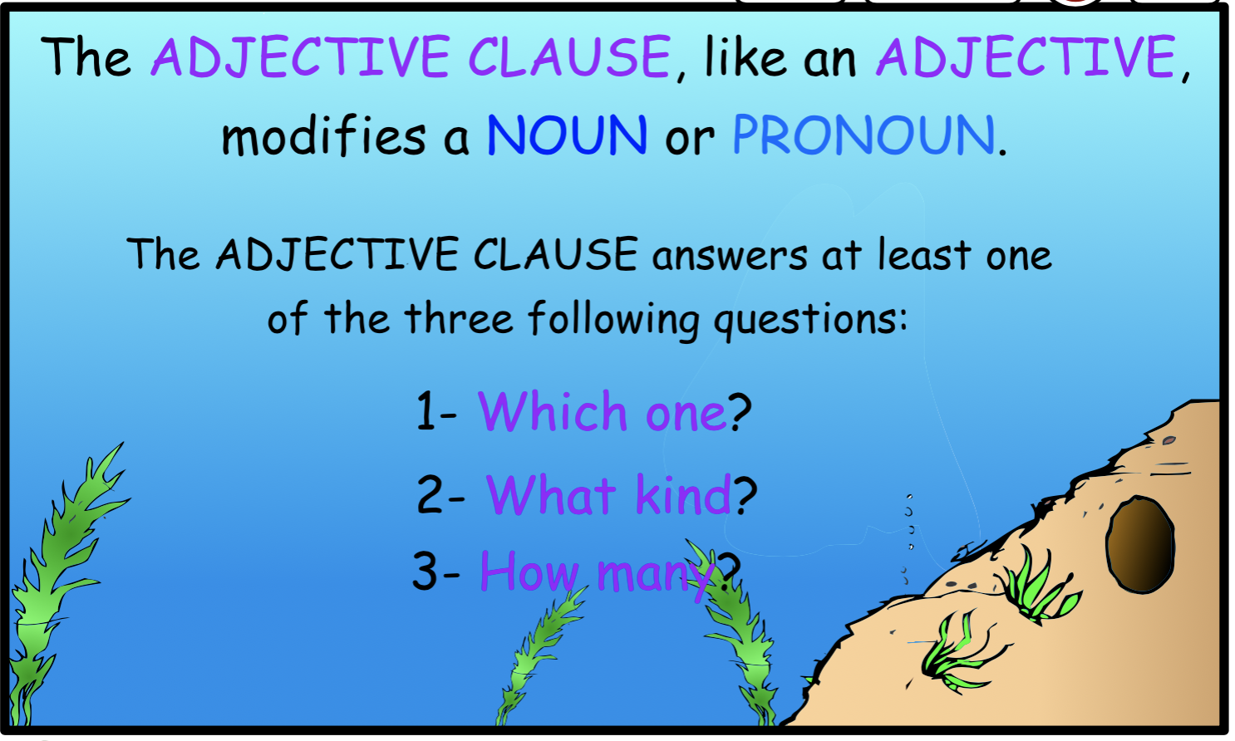

The CLAUSE contains a subject and a verb and is linked to the main sentence by a subordinate conjunction or relative pronoun.

The ADJECTIVE CLAUSE like an ADJECTIVE modifies a noun or pronoun. 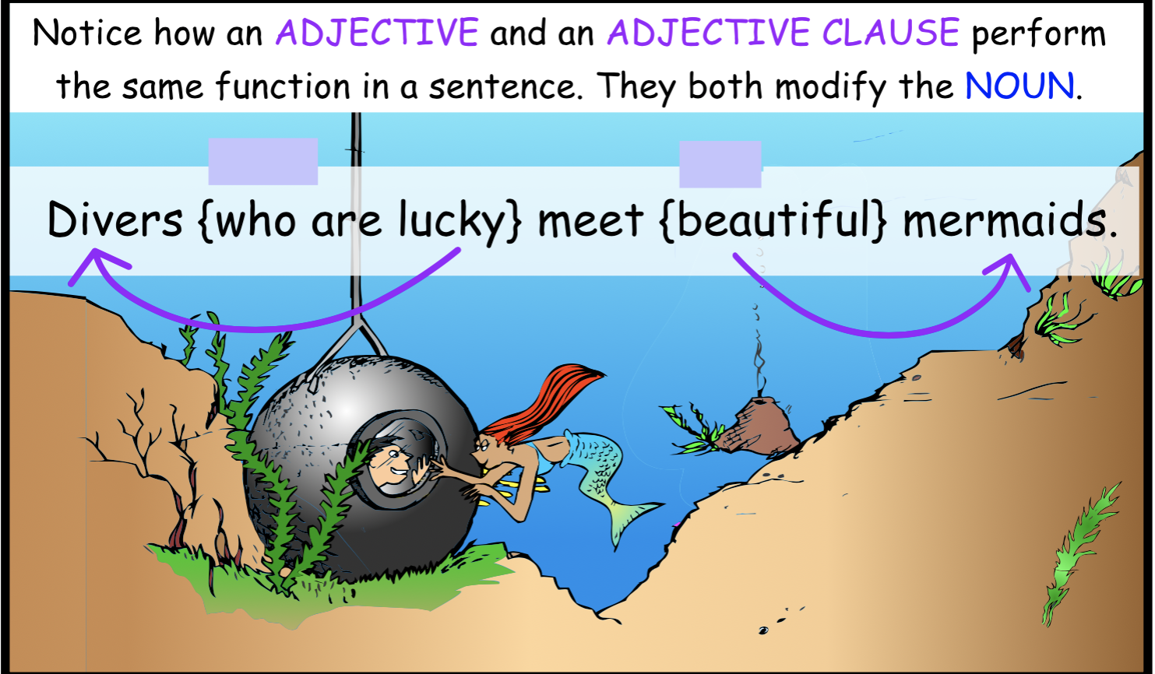

There is a printable quiz below.

ADJECTIVE CLAUSES
Identify ADJECTIVE CLAUSES in the following sentences. Place commas around the ADJECTIVE CLAUSES in the sentences.

- Sam who is fascinated by the sea loves descending in his diving bell.

- Sam’s diving bell which is pressurized can be lowered deep into the ocean.

- Out of the shadows swam a figure whose beauty took Sam’s breath away.

- The mermaid who noticed this strange creature swam up to the bell.

- Mermaids who live in the sea don’t see humans very often.

- The mermaid who has red flowing hair is delighted to see Sam.

- Sam who is in the diving bell was shocked to see the mermaid.

- The mermaid who noticed his wide eyes came closer to the bell.

- Sam who had never seen a mermaid before was completely charmed by the mermaid.

- The sea which had always been his favorite place now became the keeper of his heart.

Answers to the ADJECTIVE CLAUSE quiz:

- Sam, who is fascinated by the sea, loves descending in his diving bell.

- Sam’s diving bell, which is pressurized, can be lowered deep into the ocean.

- Out of the shadows swam a figure, whose beauty took Sam’s breath away.

- The mermaid, who noticed this strange creature, swam up to the bell.

- Mermaids, who live in the sea, don’t see humans very often.

- The mermaid, who has red flowing hair, is delighted to see Sam.

- Sam, who is in the diving bell, was shocked to see the mermaid.

- The mermaid, who noticed his wide eyes, came closer to the bell.

- Sam, who had never seen a mermaid before, was completely charmed by the mermaid.

- The sea, which had always been his favorite place, now became the keeper of his heart.

