REGULAR AND IRREGULAR VERBS

REGULAR and IRREGULAR VERBS form the
past-tense and past participle in different ways.
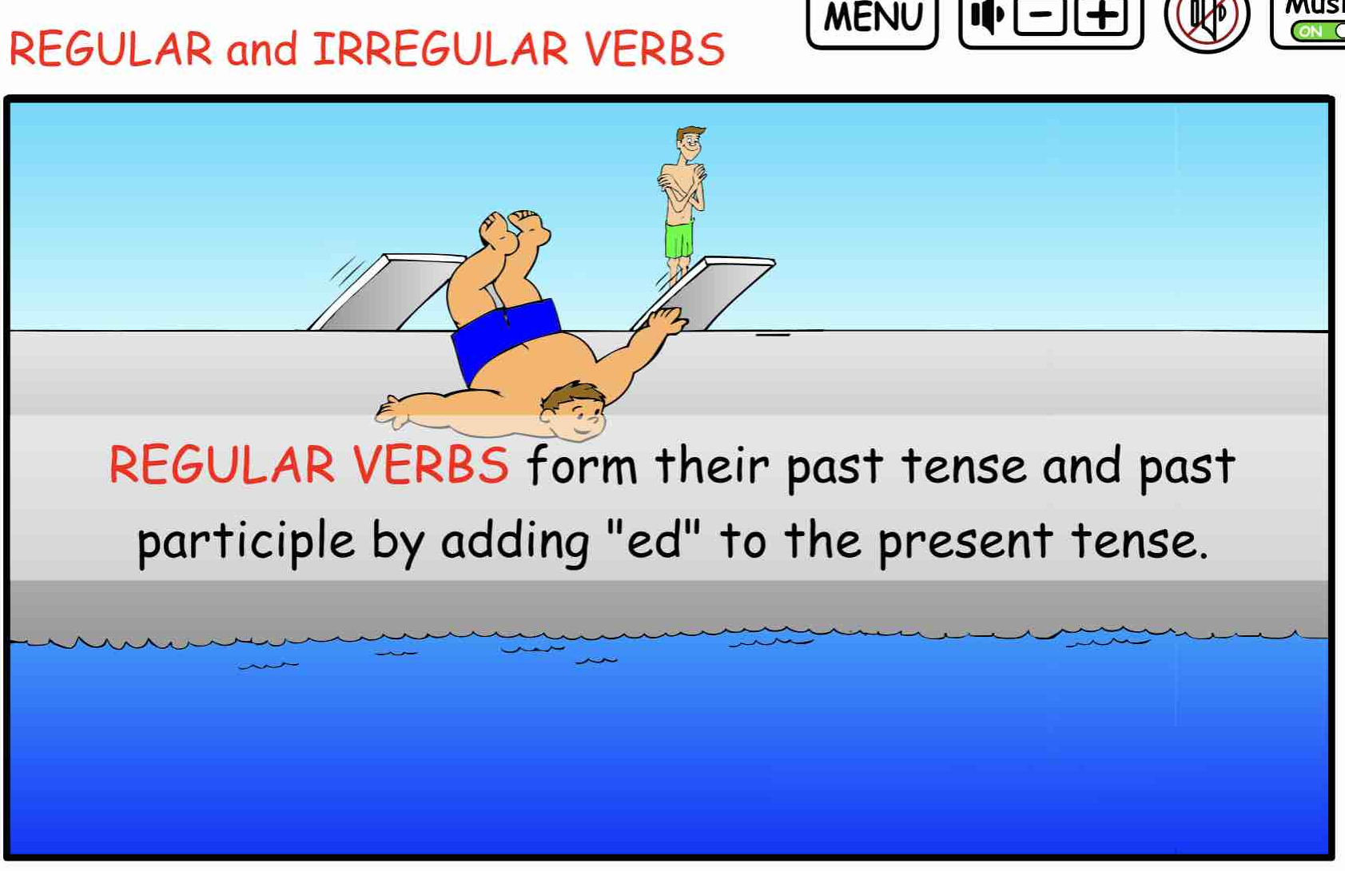
Regular Verbs form their past tens and past participle
by simply adding ED to the present tense.
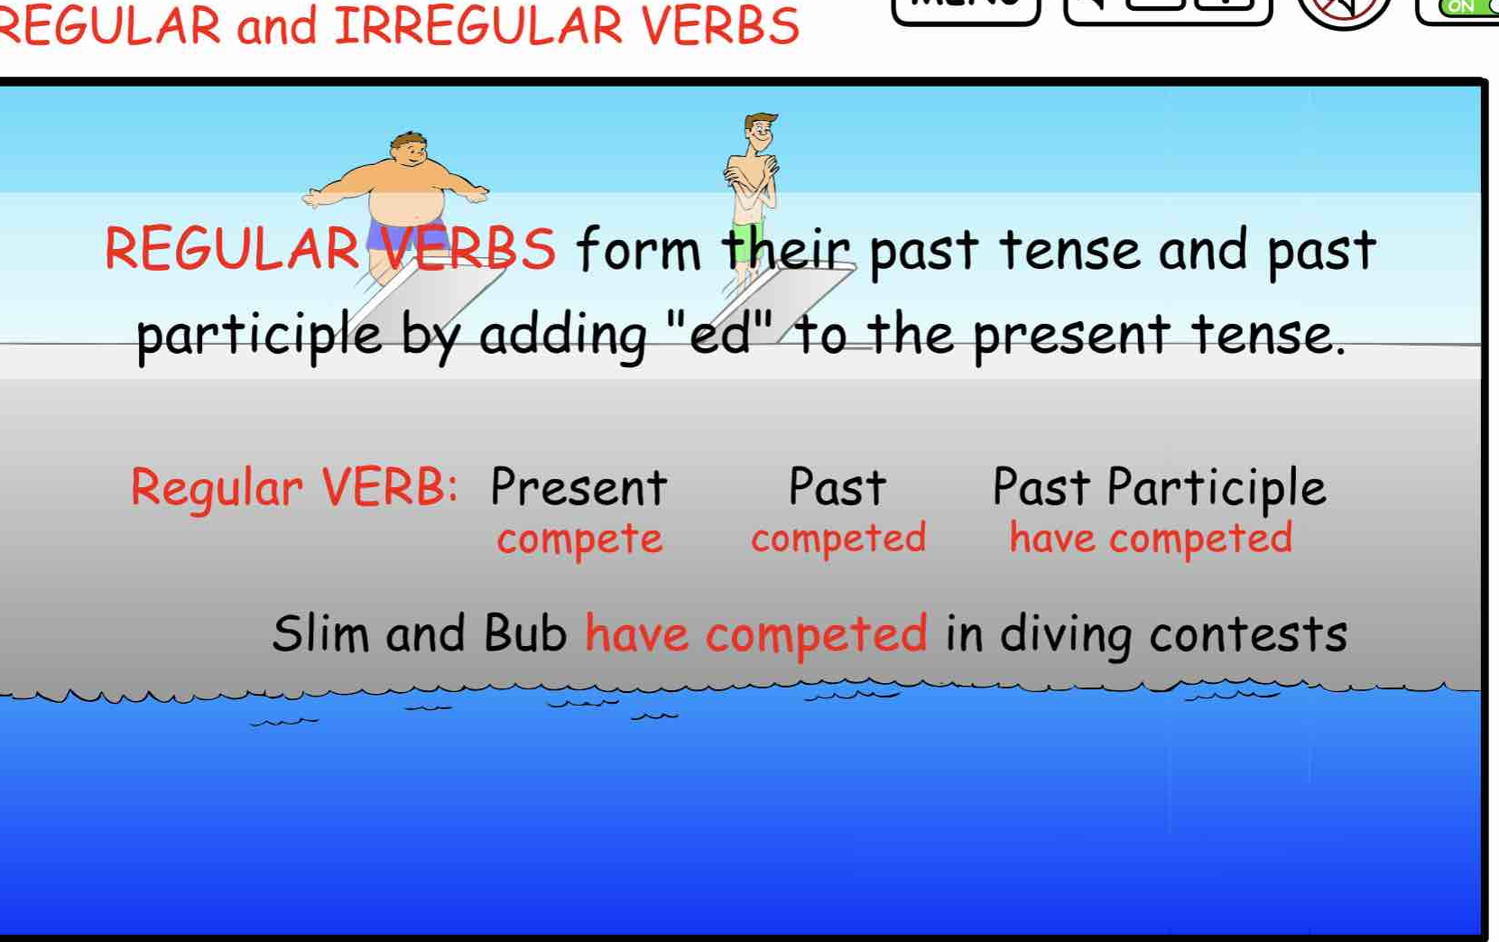
NOTICE: The PAST PARTICIPLE is always preceded by
a form of the auxiliary verb HAVE.
Bub has completed his dive.
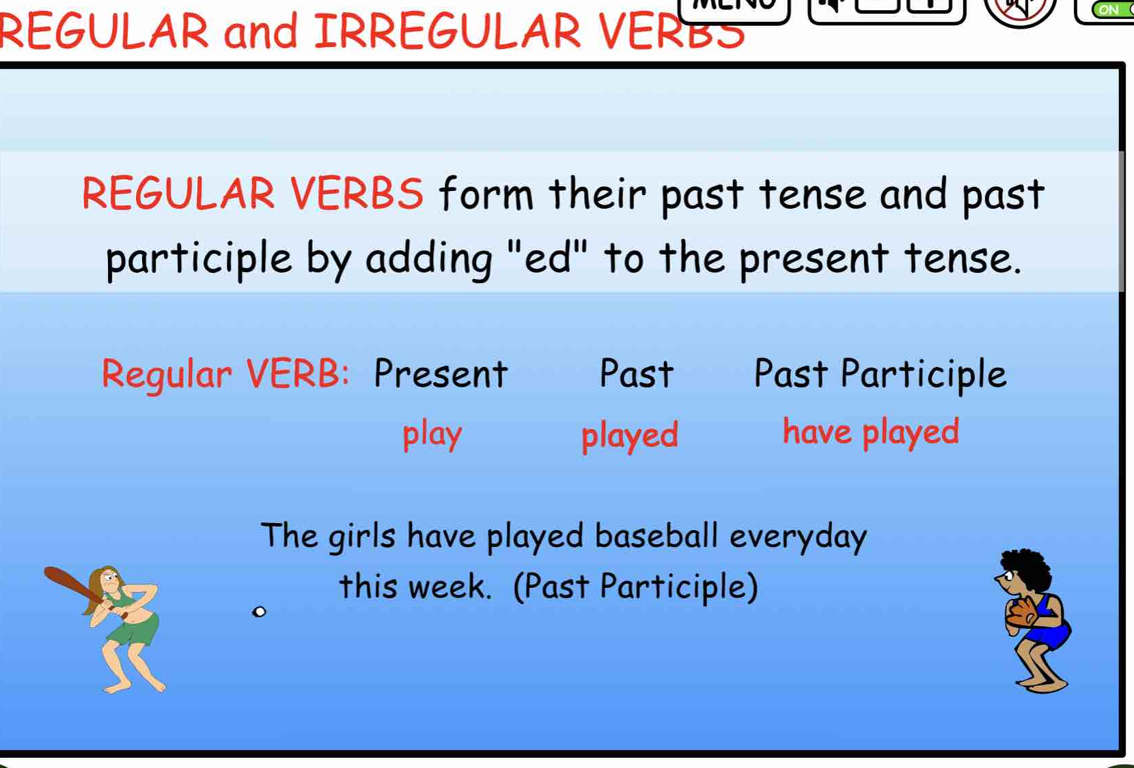
Sample sentences:
The girls play softball every day.
They played for three hours on Tuesday.
The girls have played softball competitions each summer.
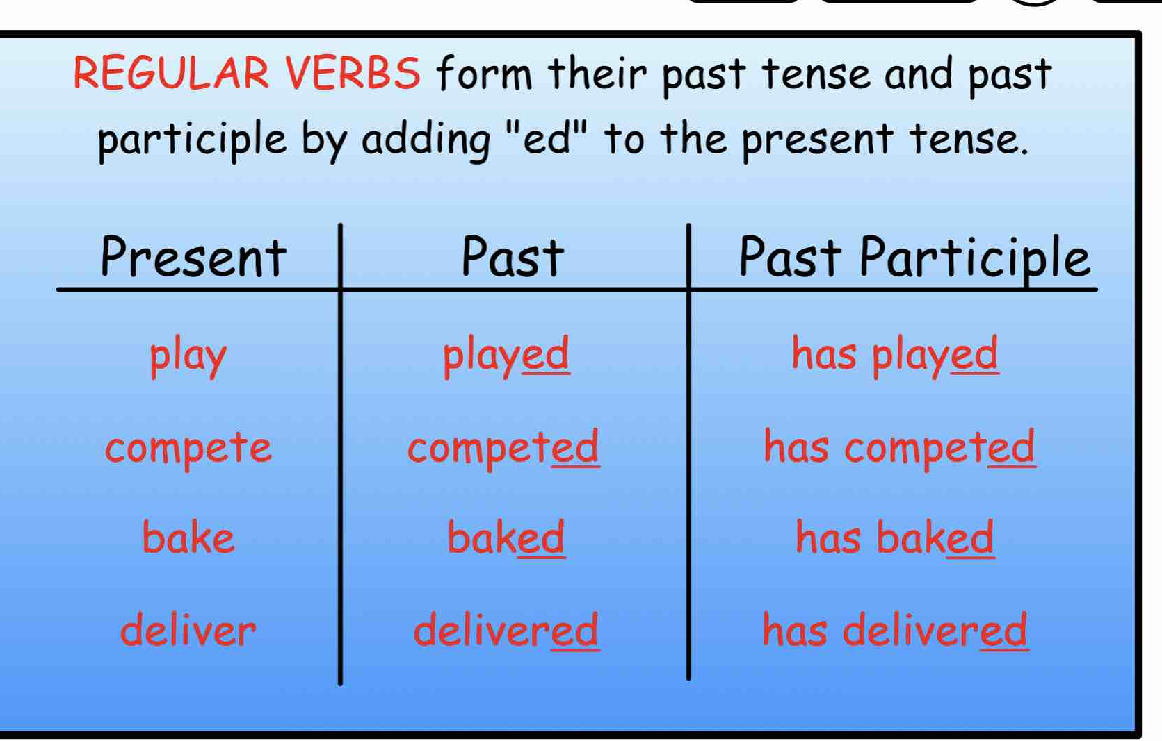
See if you can write 10 sentences using the different verb forms from the samples above.

PRINTABLE QUIZZES:
Identify the verb in the following sentence and indicate if it is the present, past, or past participle form.

- The kids play softball on the beach every weekend.
- They played a fun game last Saturday.
- The team had practiced their throws for hours.
- Barbie hits the ball far into the sand.
- Bub smacked the ball over the fence yesterday.
- Sam has joined the game with his friends.
- All the players walk along the beach after the match.
- Some players swam in the ocean after their game.
- The batters run to the bases with excitement.
- The coach has checked the beach for rocks and glass.

PRINTABLE QUIZZES:
Identify the verb in the following sentence and indicate if it is the present, past, or past participle form.

- The kids play softball on the beach every weekend. Present
- They played a fun game last Saturday. Past
- The team had practiced their throws for hours. Past Part.
- Barbie hits the ball far into the sand. Present
- Bub smacked the ball over the fence yesterday. Past
- Sam has joined the game with his friends. Past Part.
- All players walk along the beach after the match. Present
- The team played in the ocean after their game. Past
- The batters rush to the bases with excitement. Present
- The coach has checked the beach for rocks and glass. Past Part.

