IRREGULAR VERBS
IRREGULAR VERBS form their past tense and past participle by using different words.
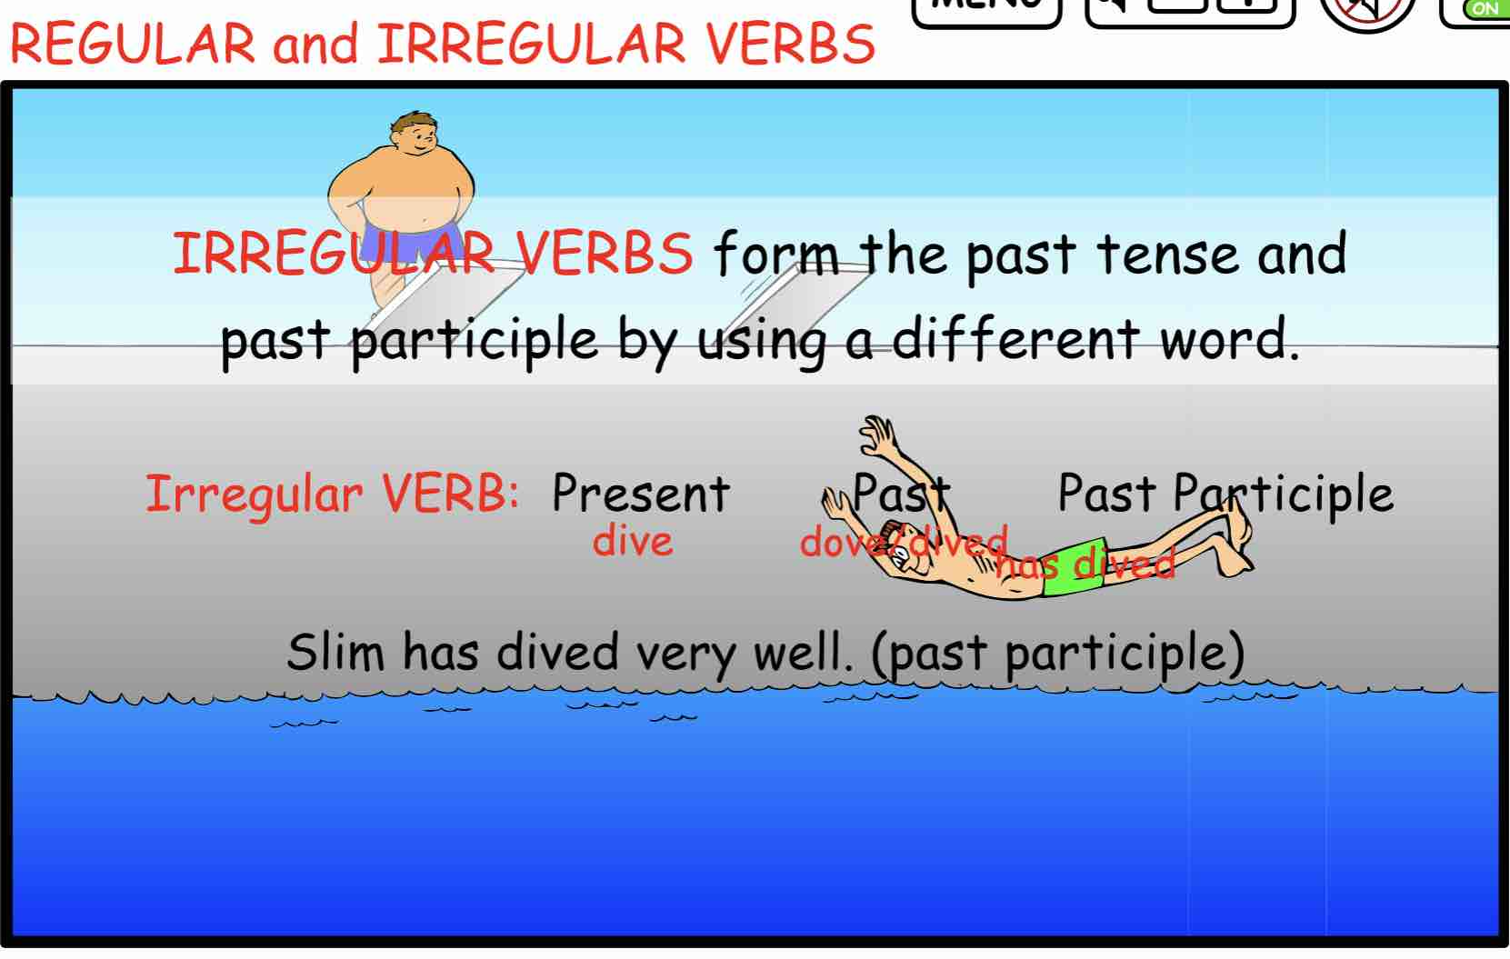
Example:The verb DIVE uses DOVE for the past tense and
HAVE DIVED for the past participle.
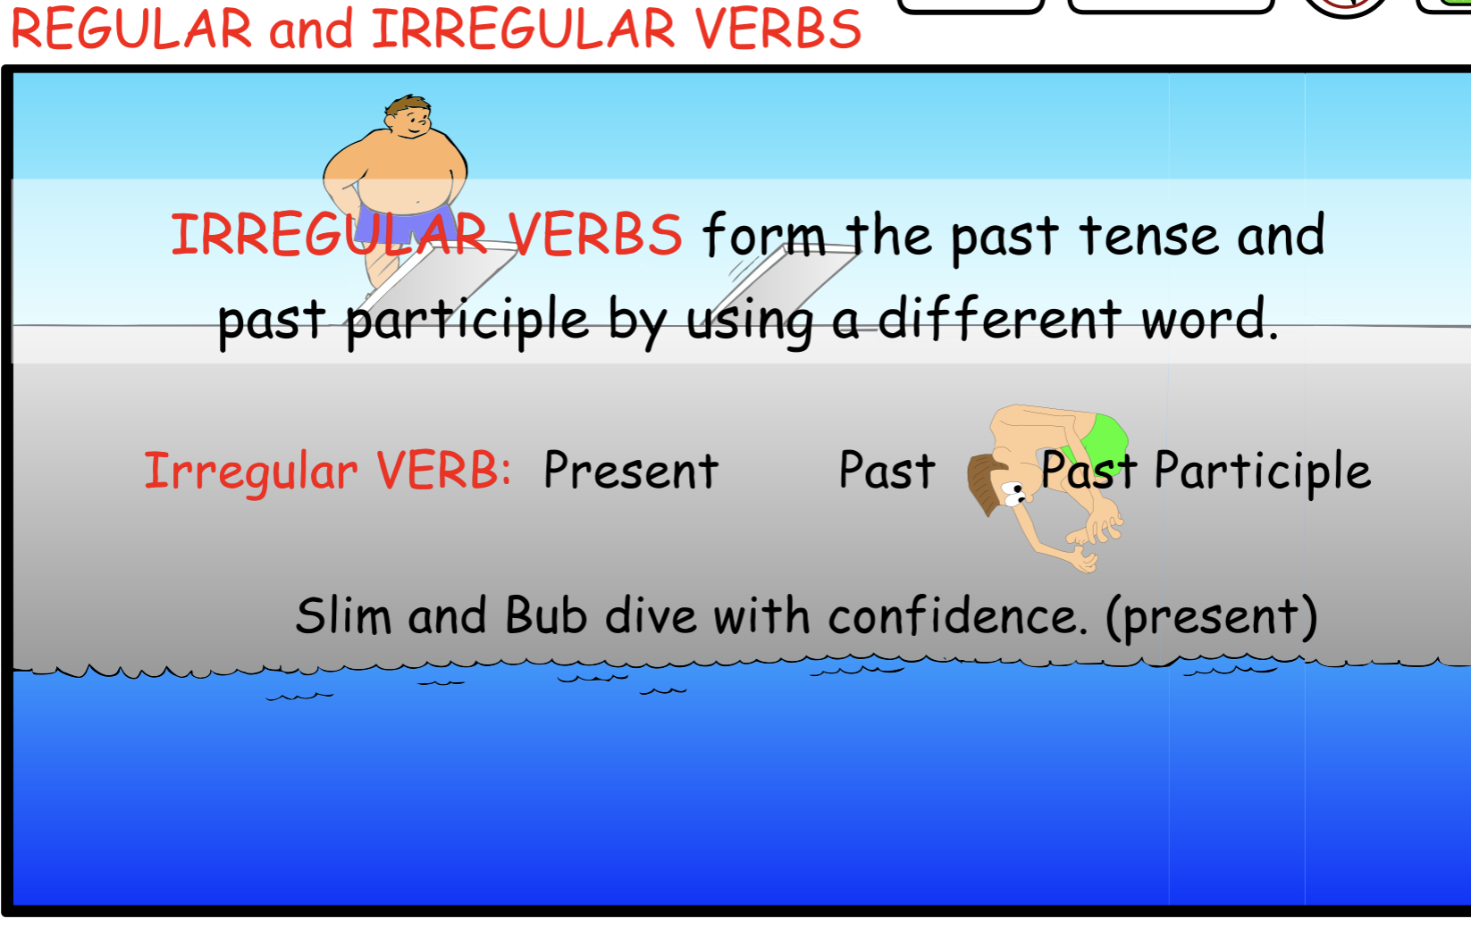
Notice that the verb FLY uses FLEW and HAS FLOWN.

FLY is the present tense, FLEW is the past tense
and HAS FLOWN is the past participle.
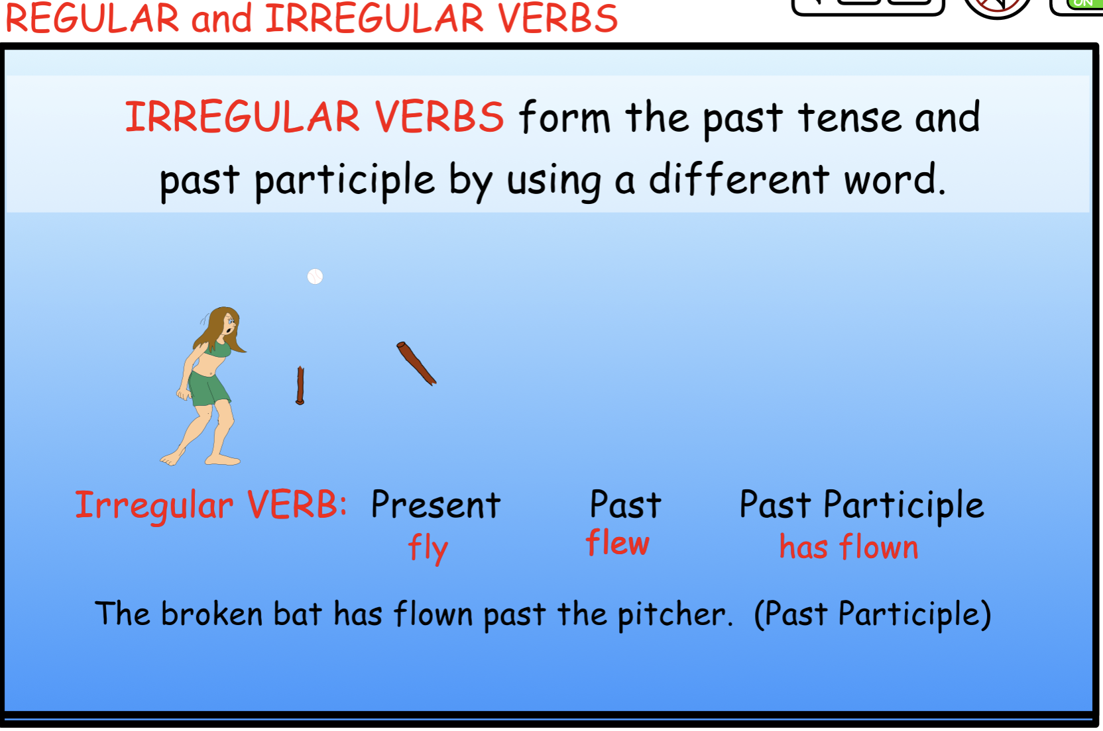
There are many irregular verbs you should know.

Some of the more common irregular verbs are:
You do the cooking. I did the shopping.
We have done the dishes
We buy packs of gum, but you bought the entire crate.
You begin the puzzle. I began one earlier.
He has begun that one already.



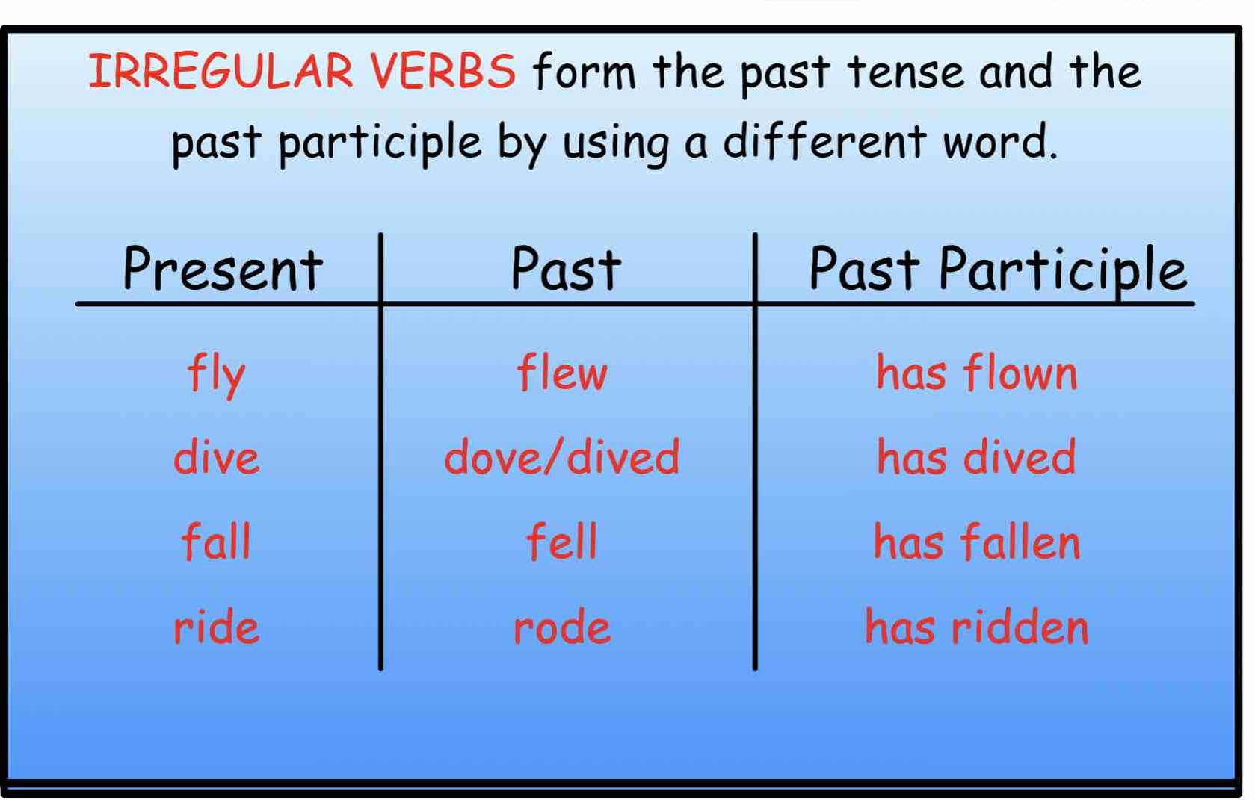
Write 10 sentences using the irregular verbs
from the chart above.

Identify the verb tense forms in the sentences below.
PRESENT, PAST, or PAST PARTICIPLE
- He ran across the sand to catch the ball.
2. They have run many laps around the field.
3. She throws the ball to her teammate.
4. He threw the ball to first base quickly.
5. The team has thrown many pitches today.
6. They catch the ball with great skill.
7. She caught the ball with one hand during the game.
8. The players have caught several fly balls.
9. The kids enjoy playing on the soft sand.
10.They have enjoyed the games after school.

Answers to the above IRREGULAR VERB sentences:

- He ran across the sand to catch the ball. Present
- They have run many laps around the field. Past Part.
- She throws the ball to her teammate. Present
- He threw the ball to first base quickly. Past
- The team has thrown many pitches today. Past Part.
- They catch the ball with great skill. Present
- She caught the ball with one hand during the game. Past
- The players have caught several fly balls. Past Part.
- The kids enjoy playing on the soft sand. Present
- They have enjoyed the games after school. Past Part.

