The INDIRECT OBJECT is the NOUN or PRONOUN
TO whom or FOR whom the verb's action is performed.
(The Indirect Object is never preceded by a preposition.)
EXAMPLES: We gave him the answer. Ann baked him a pie.

INDIRECT OBJECTS

The INDIRECT OBJECT answers
TO WHOM or FOR WHOM
the verb’s action is performed.

The PRONOUN used in Direct Objects will always be in the OBJECTIVE CASE.
OBJECTIVE CASE--the pronoun form used for direct and indirect objects of verbs and verbals,
for objects of prepositions, and for subjects of infinitive phrases.
WHOM is used only for the direct and indirect objects of verbs and verbals,
for the object of a preposition, and for the subject of an infinitive phrase.

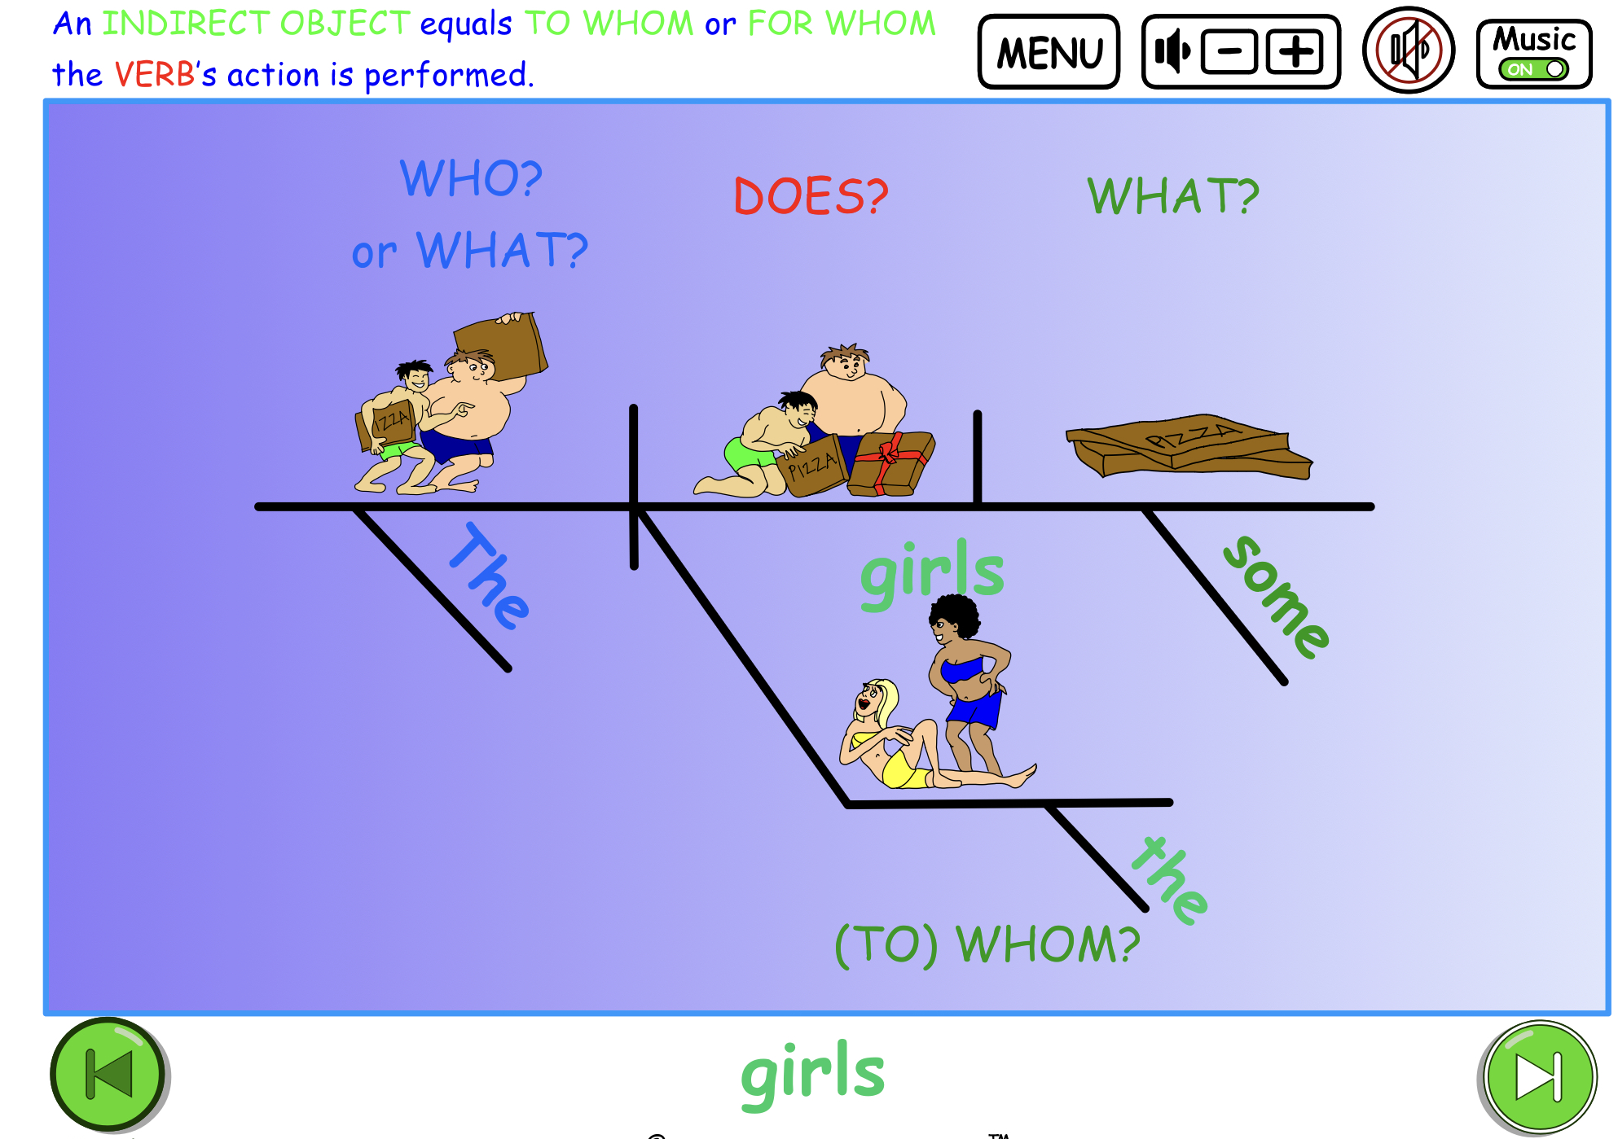

To find the Indirect Object ask TO WHOM or FOR WHOM the verb’s action is performed.

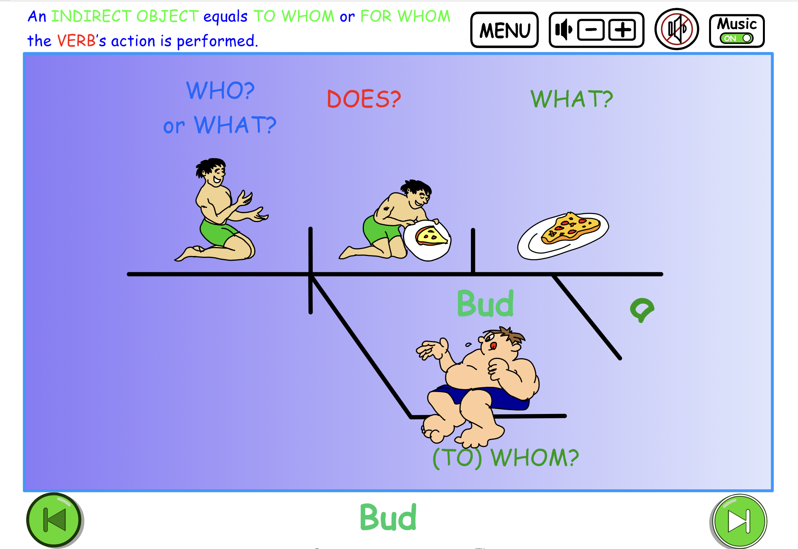
Around
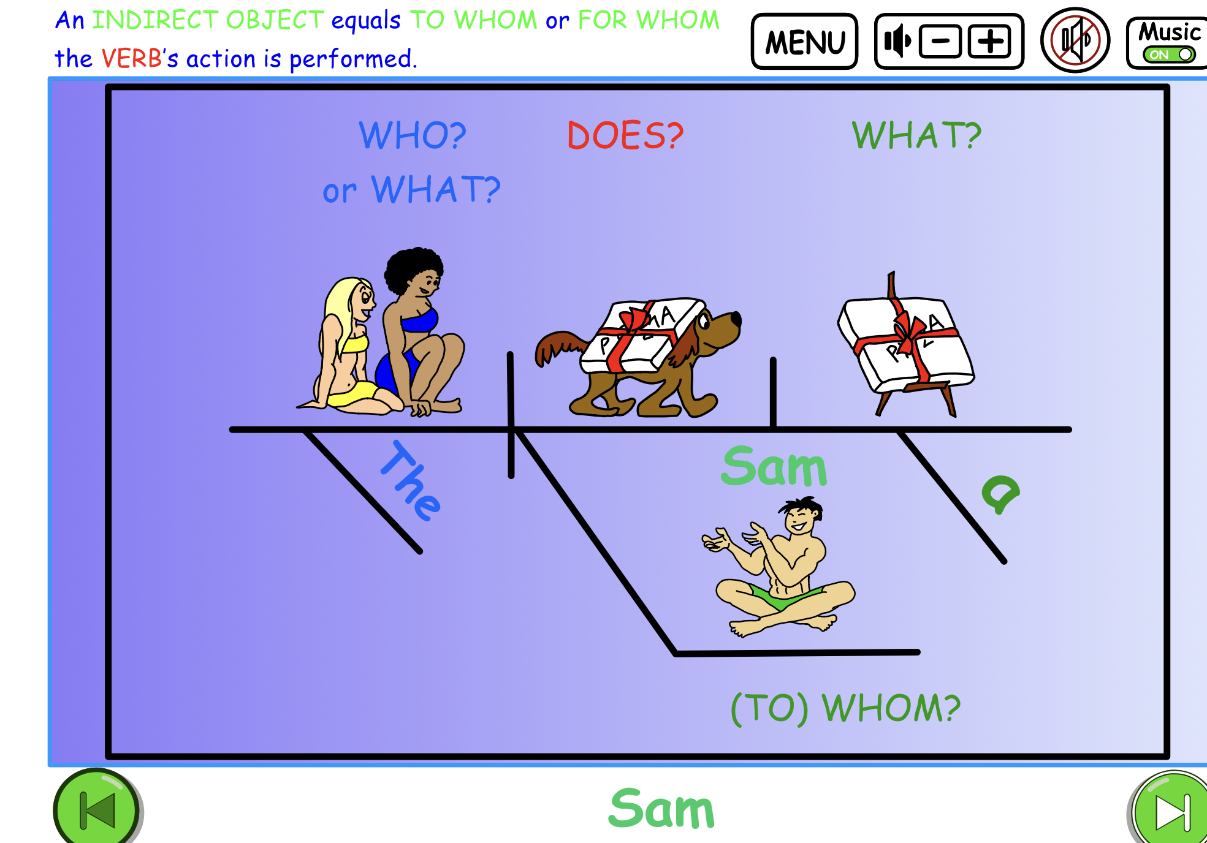

Diagramming sentences helps to see the relationship of the
INDIRECT OBJECT to the DIRECT OBJECT.

Printable Indirect Object quiz questions.
Indirect Object Quiz for Lesson Plans
Identify the DIRECT and INDIRECT OBJECTS in the sentences below.
An indirect object is typically the recipient of the direct object and
answers the question “to whom?” or “for whom?” something is done.
Try to diagram these sentences.
- Barf gave his friend a hotdog.

- Twiggs wrote her sister a long email.

- Sam is sending his English teacher an email.

- The surfing coach brought us lunch.

- Mick made his little brother a sandcastle.

- The surfing champ told the team a scary story.

- Bub showed everyone his new phone.

- Twiggs baked the team some cookies.

- Rita gave her brother surfing lessons.

- Twiggs passed Bub the hot dogs.

Answers:
The INDIRECT OBJECTS are listed in red. The adjective pronouns are bolded. The DIRECT OBJECTS are indicated in blue.
- Barf gave his friend a hotdog.
- Twiggs wrote her sister a long email.
- Sam is sending his English teacher an email. d
- The surfing coach brought us lunch.
- Mick made his little brother a sandcastle.
- The surfing champ told the team a scary story.
- Bub showed everyone his new phone.
- Twiggs baked the team some cookies.
- Rita gave her brother surfing lessons.
- Twiggs passed Bub the hot dogs.

