The DIRECT OBJECT is a NOUN or PRONOUN that
receives VERB’S ACTION.
It answers WHOM or WHAT after the verb.
It is one of the 5 PREDICATE COMPLIMENTS.
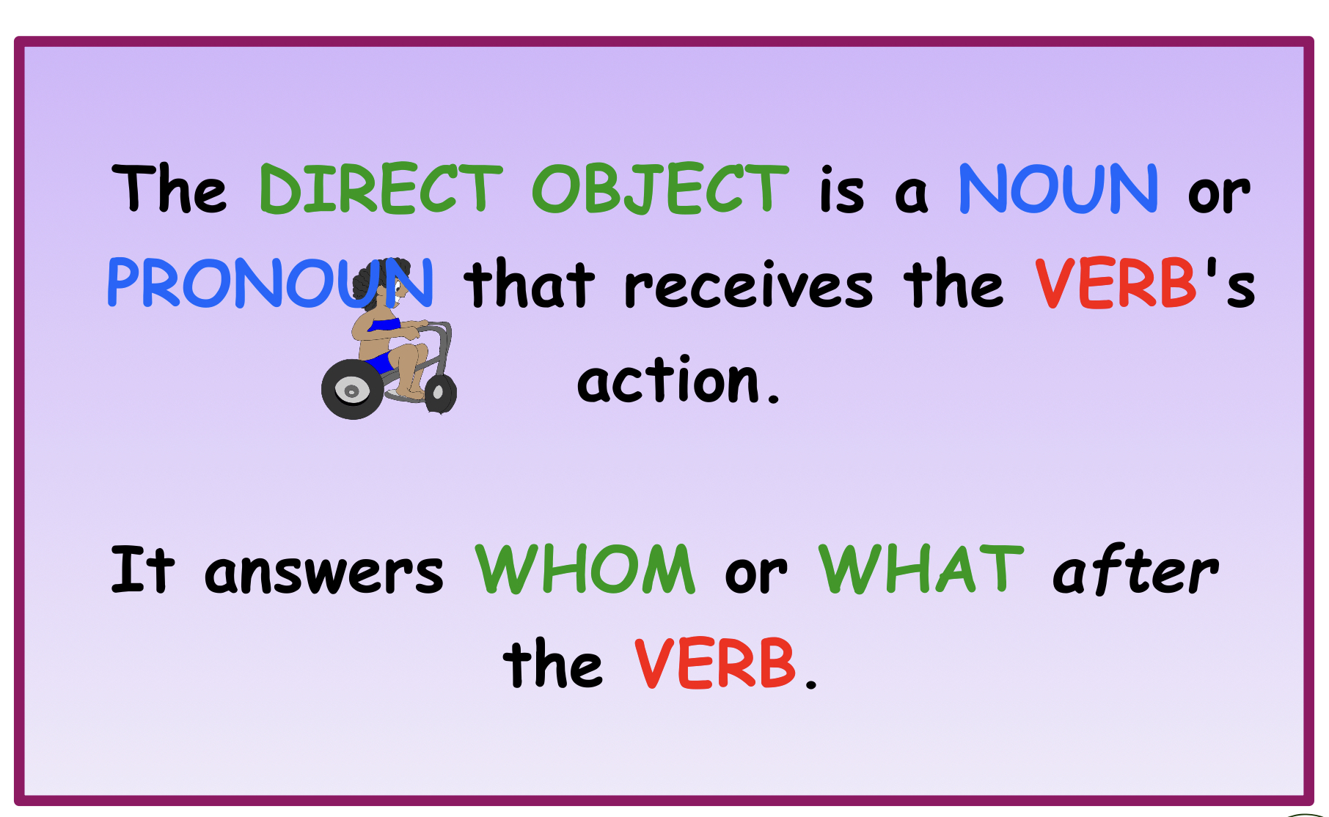
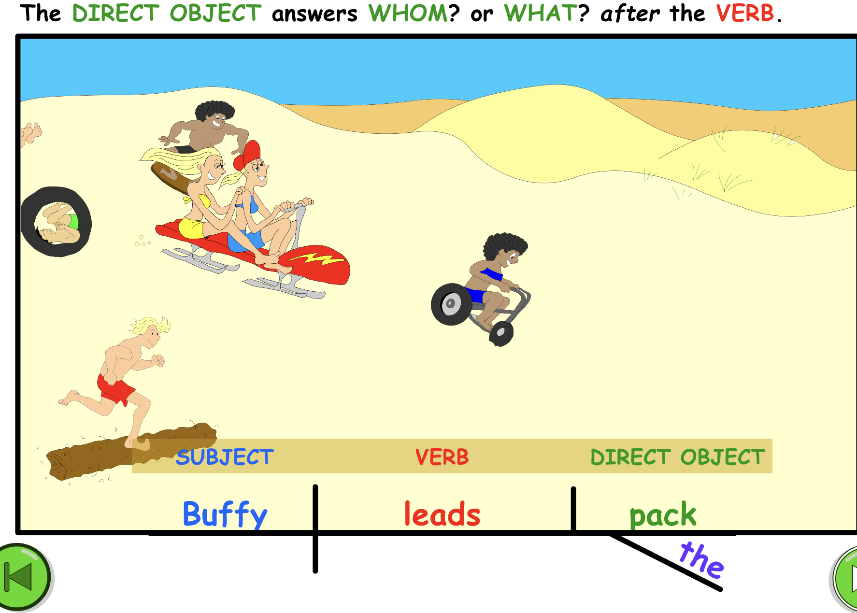
Notice in the diagram how the DIRECT OBJECT completes the action.

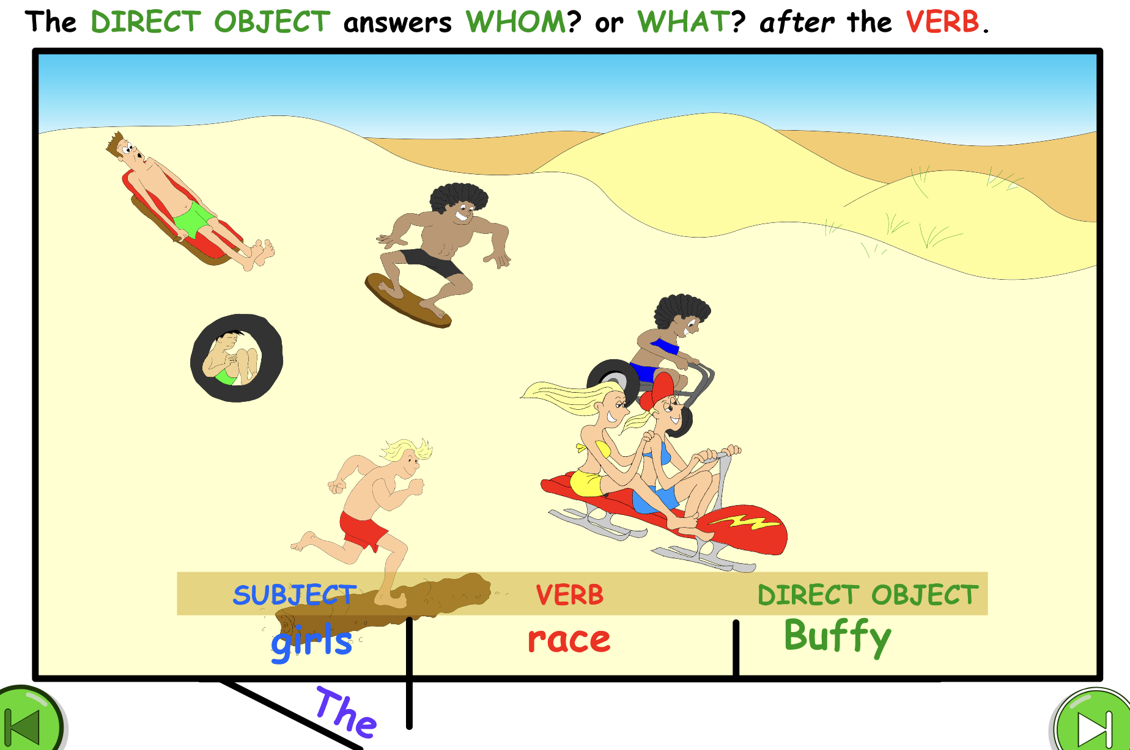

Diagramming the sentence help show the relationship of the Direct Object
To the ACTION VERB and the SUBJECT. It also helps in finding the Direct Object
because it clearly shows WHO or WHAT after the verb.
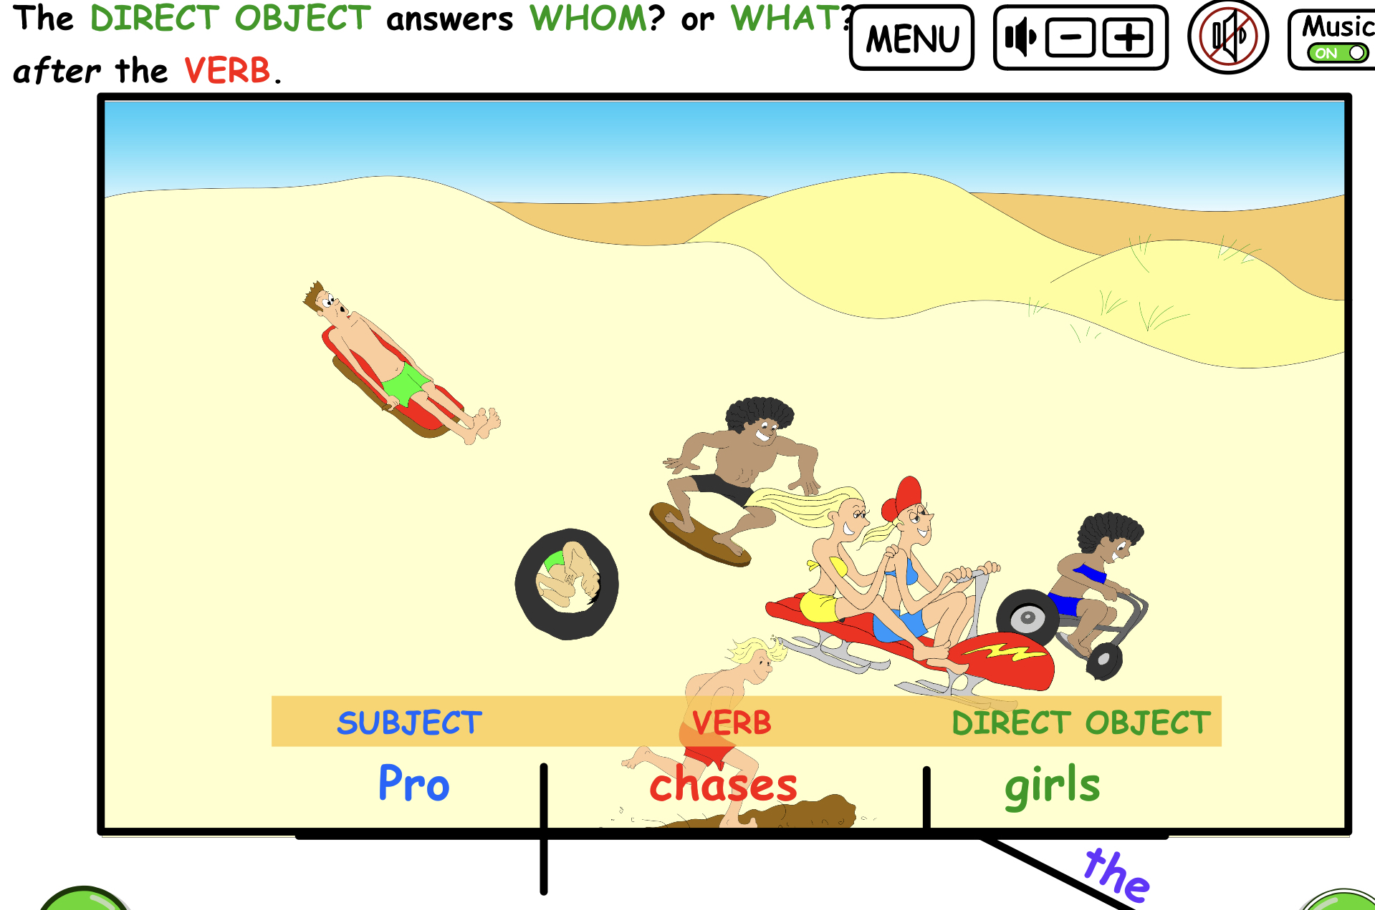
ASK the questions WHOM or WHAT does Pro chase?
The answer is the girls and that is the DIRECT OBJECT in this sentence.

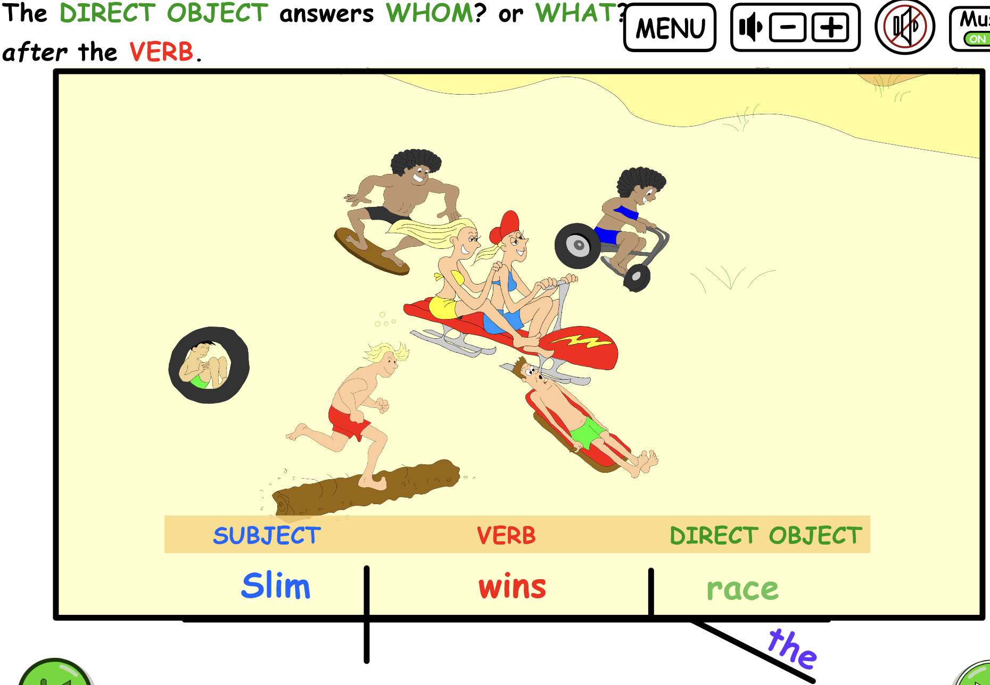

Ask, “Slim wins what?” and the answer is the race.
The word RACE is the DIRECT OBJECT in this sentence.

Notice that the DIRECT OBJECT always answers the questions
WHOm or WHAT after the action verb.

Printable Direct Object Quiz Sentences

Underline the ACTION Verb once and
the Direct Objects twice.

- Doog bought a new surfboard.
- Twiggs surfs on a longboard.
- The surfers built a beach hut.
- The team manager filmed a surfing movie.
- Barf chased the beach crabs.
- Rita took a team photo.
- Mick fixed the surfboard rack.
- Sam built a BBQ grill.
- The team roasted hotdogs.
- Barbi wore a new backpack.

QUIZ ANSWERS: VERBS ARE IN RED, DIRECT OBJECTS ARE BOLDED.
- Doog bought a new surfboard.
- Twiggs surfs on a longboard.
- The surfers built a beach hut.
- The team manager filmed a surfing movie.
- Barf chased the beach crabs.
- Rita took a team photo.
- Mick fixed the surfboard rack.
- Sam built a BBQ grill.
- The team roasted hotdogs.
- Barbi wore a new backpack.

