COMMAS SEPARATE ADJECTIVES
MODIFYING THE SAME NOUN.
When two or more adjectives modify the same noun,
separate them with commas.
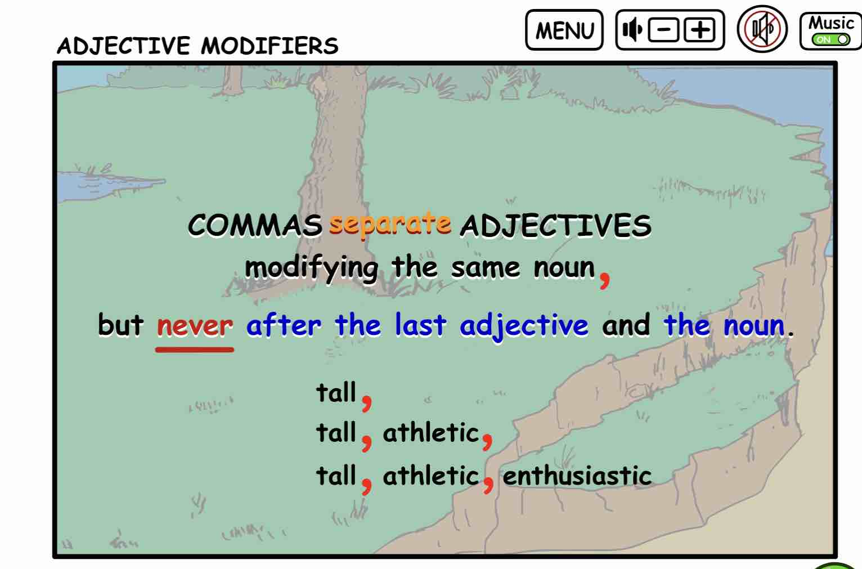
Remember never use a comma
after the last adjective before the noun.
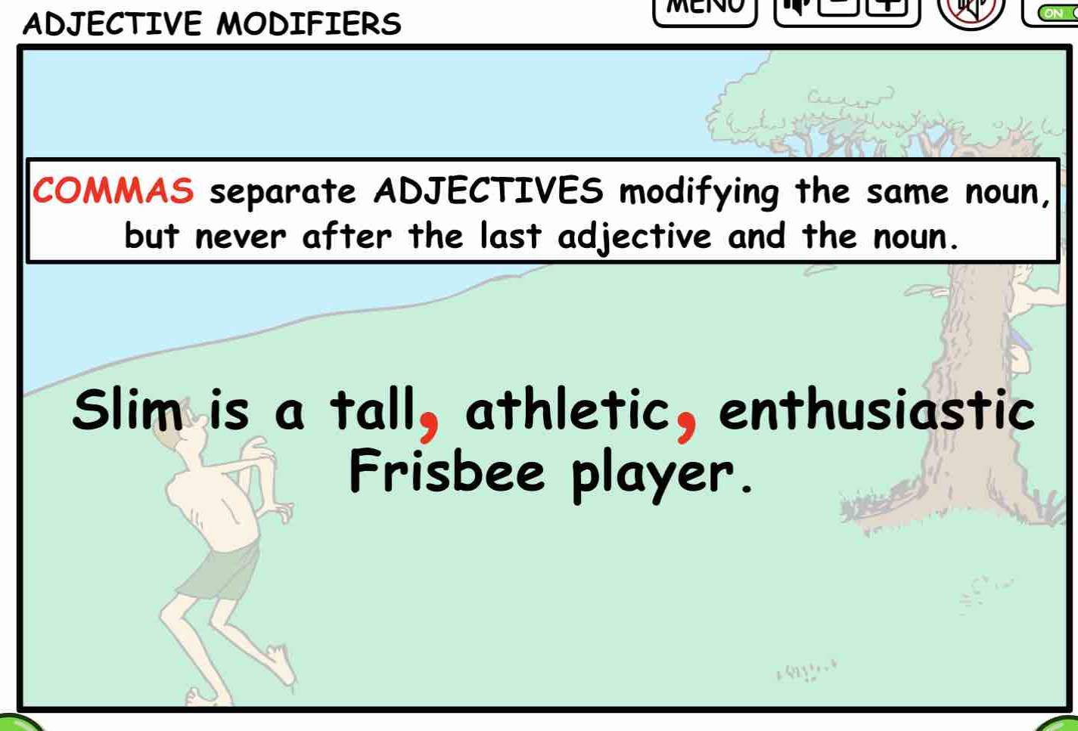
Remember that ADJECTIVES answer
- WHICH ONE?
- WHAT KIND?
- HOW MANY?
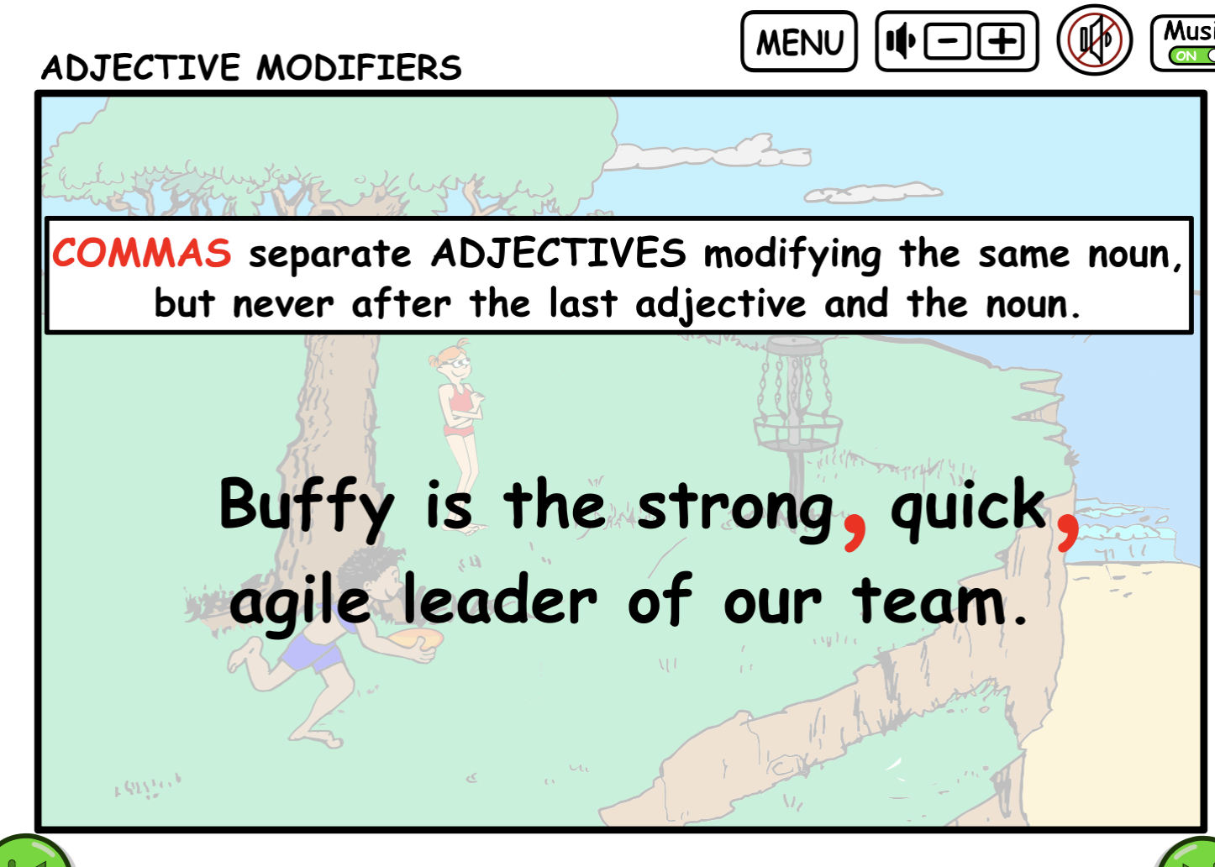

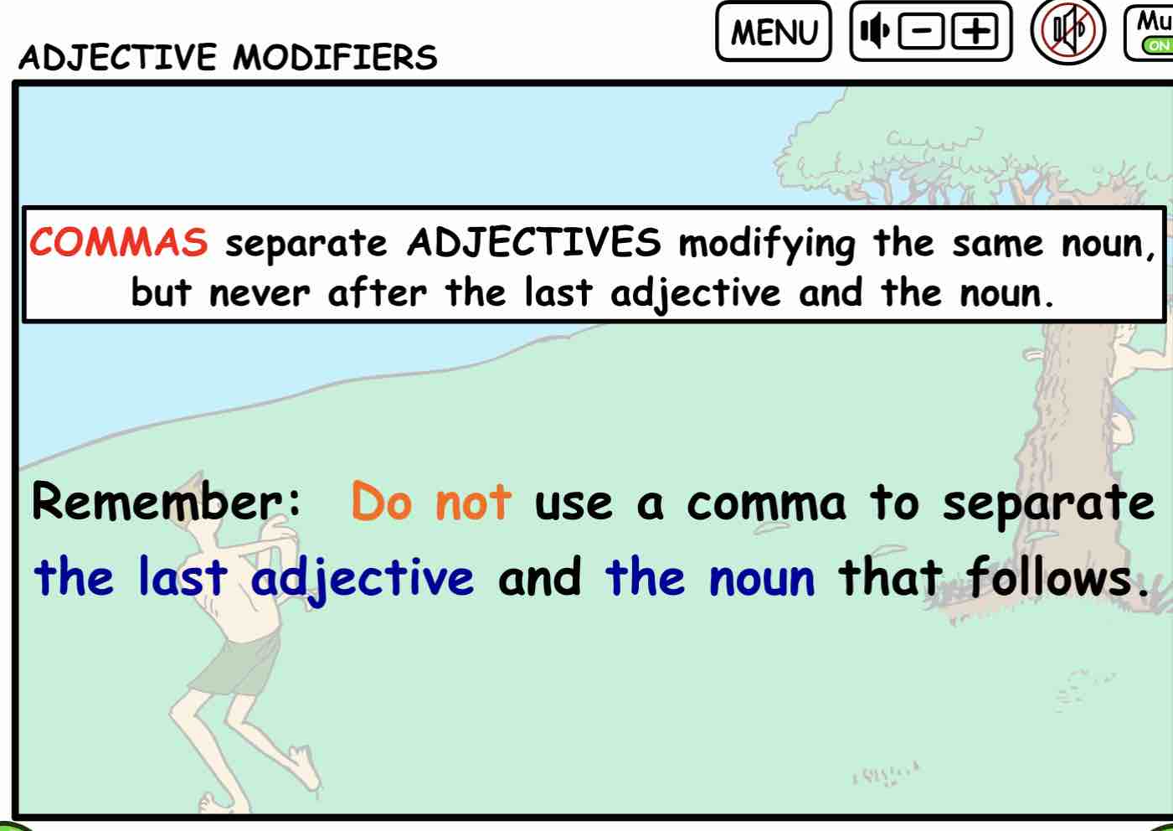

Practice punctuating sentences that contain
multiple adjectives modifying the same noun.

Printable quiz sentences for Commas Separate Adjective modifying the same noun.
Place the comma where needed in the following sentences.

- Tigers are strong fast and powerful.

- The snow leopard has thick soft white fur.

- The blue whale is huge graceful and mysterious.

- The red panda is small fluffy but playful.

- Sea turtles are slow ancient and peaceful.

- Rhinos are big tough yet quiet.

- The cheetah is sleek fast and graceful.

- Polar bears are white heavy and cold-loving.

- The African wild dog is lean fast and alert.

- Macaws are colorful loud and smart.

ANSWERS to the Commas with Adjective quizzes.
- Tigers are strong, fast, and powerful.

- The snow leopard has thick, soft, white fur.

- The blue whale is huge, graceful, and mysterious.

- The red panda is small, fluffy, and playful.

- Sea turtles are slow, ancient, and peaceful.

- Rhinos are big, tough, and quiet.

- The cheetah is sleek, fast, and graceful.

- Polar bears are white, heavy, and cold-loving.

- The African wild dog is lean, fast, and alert.

- Macaws are colorful, loud, and smart.

