COMMAS SEPARATE COMPOUND SENTENCES
COMPOUND SENTENCES = 2 INDEPEENT CLAUSES joined by a COORDINATION CONJUNCTION and separated by a comma.
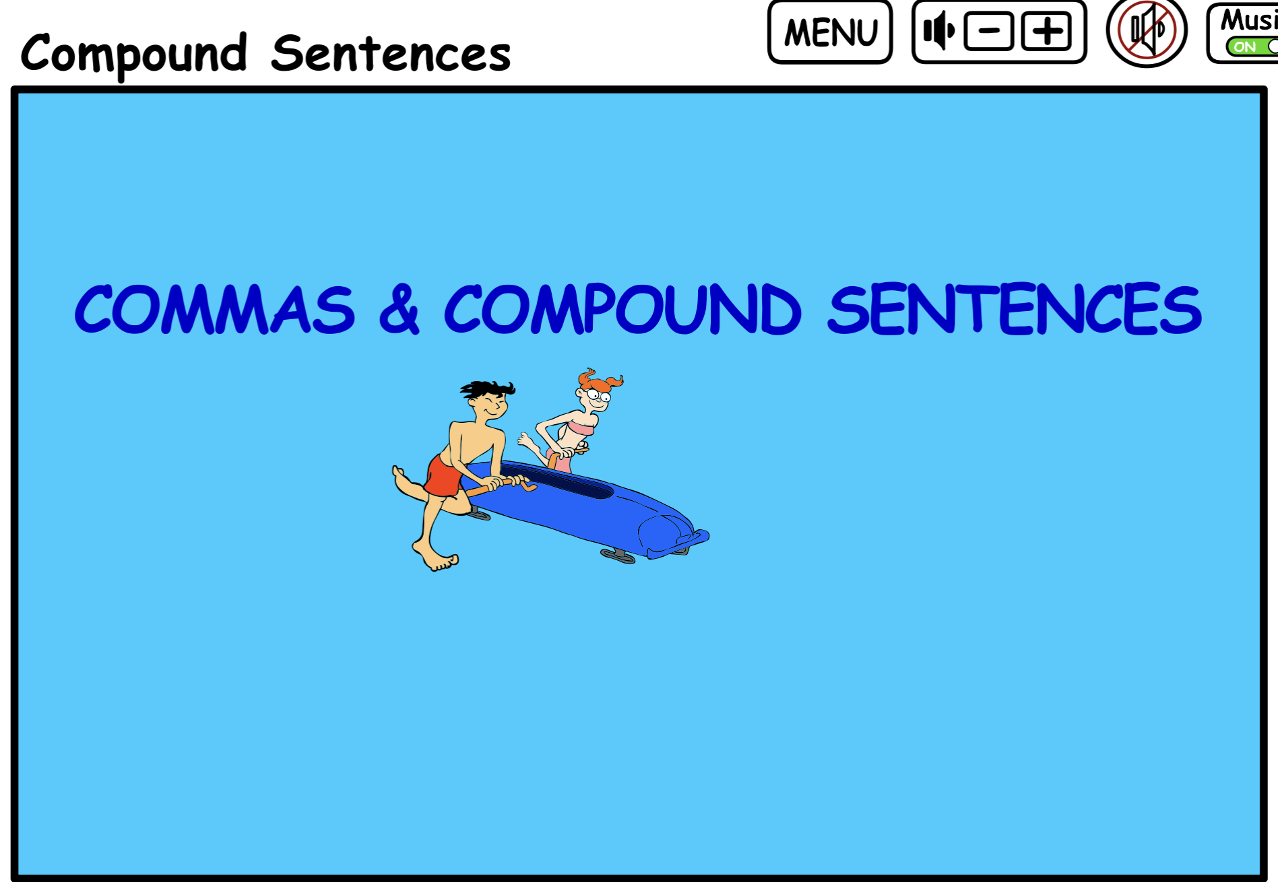
The COORDINATE CONJUNCTIONS are
AND, OR, NOR, BUT, YET, and SO!
Each INDEPENDENT CLAUSE contains a Subject and a verb.

r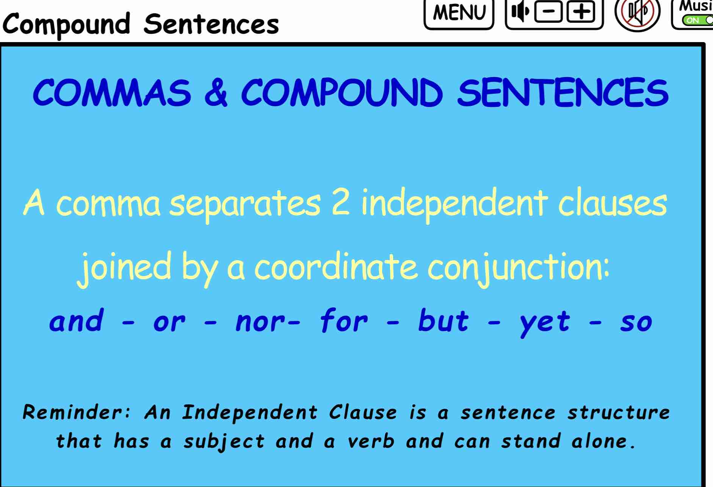b.

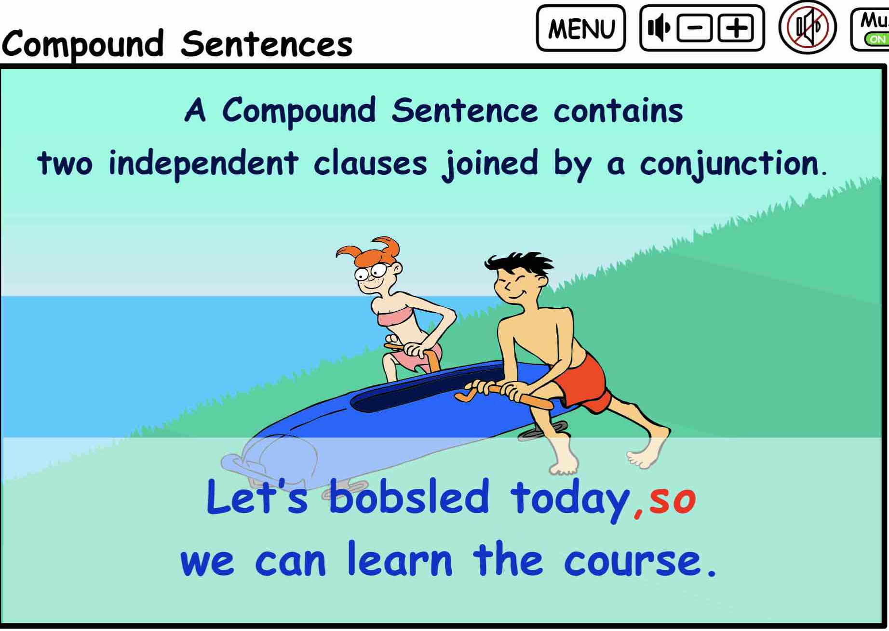

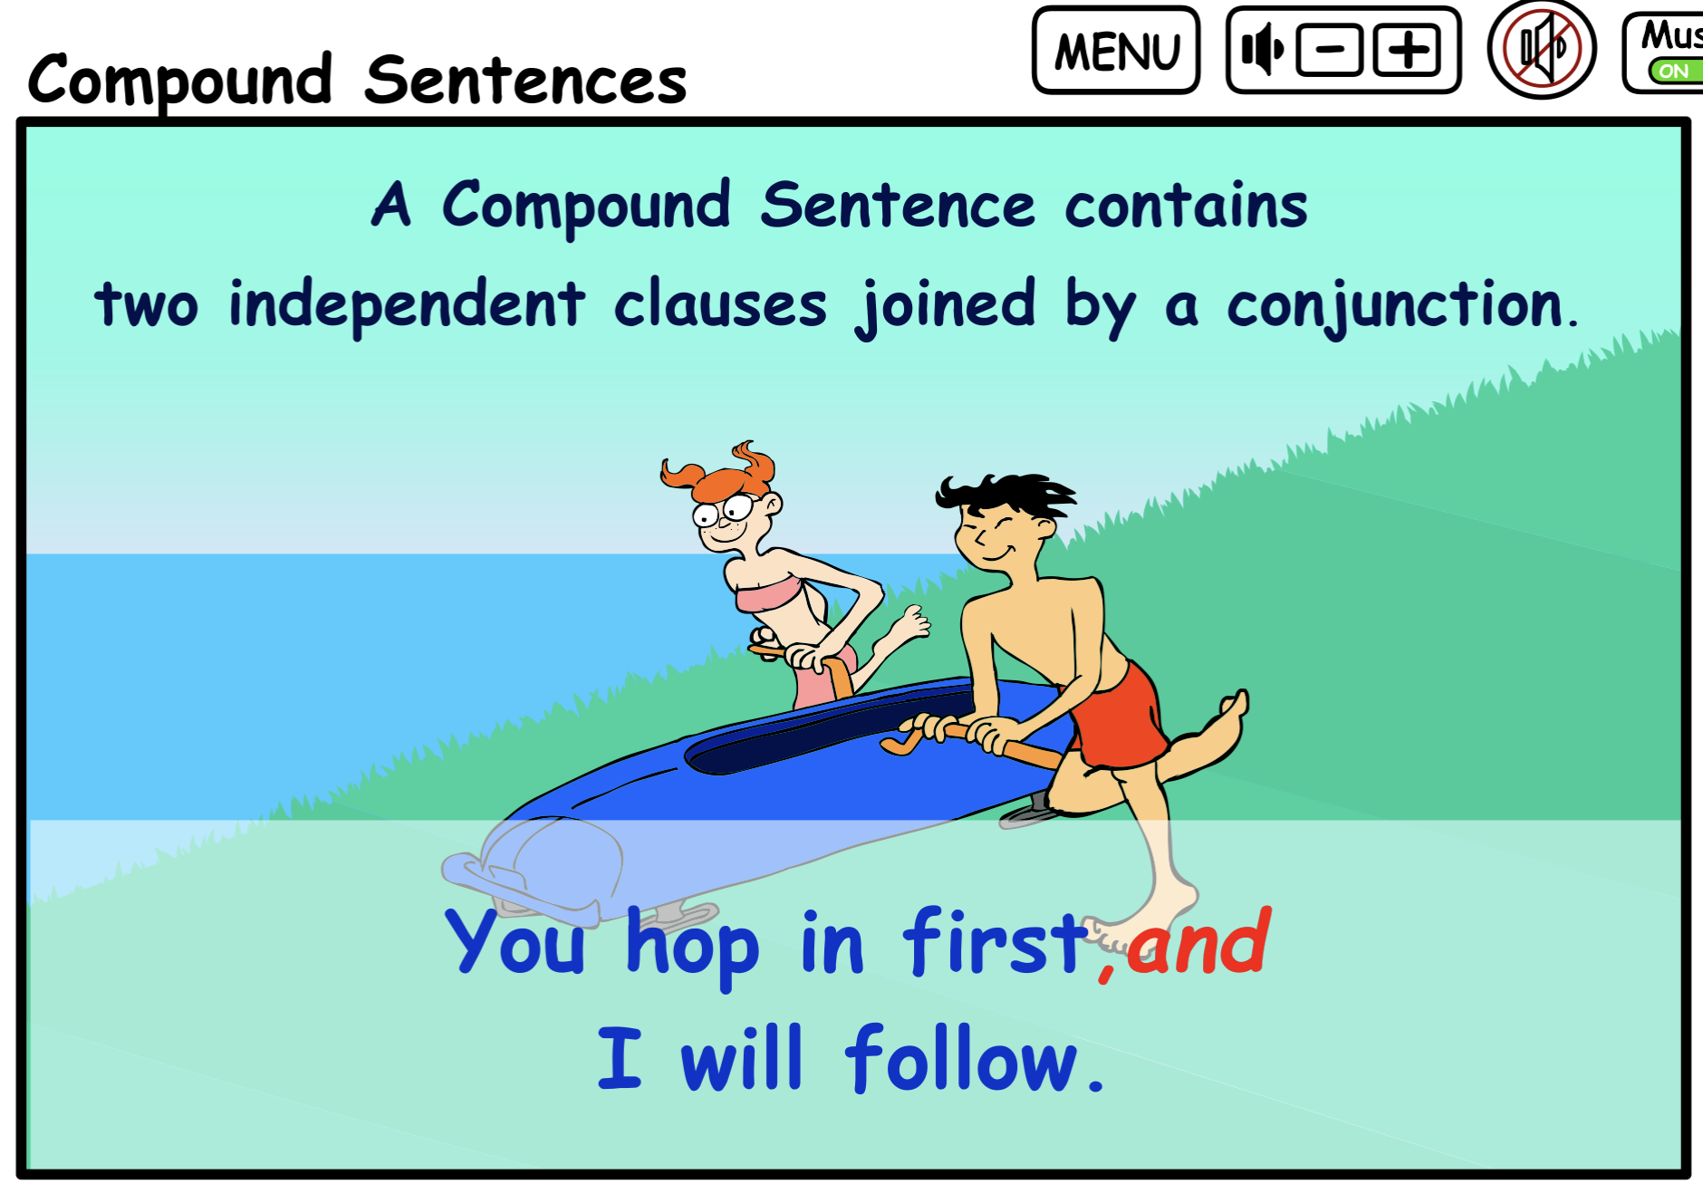

The Independent Clauses are separated by a the (, and) the coordinate conjunction.
Students should write two sentences that relate to one another and then join them with a coordinate conjunction noticing the form of these compound sentences.

PRINTABLE QUIZZES FOR COMPOUND SENTENCES.
Place each independent clause in parentheses and
insert the comma where it belongs.

- The kids saw the lions and they took picture.

- They wan1. ted to see the monkeys but the exhibit was closed.

- The children ran to the giraffes and they laughed with joy.

- It was sunny so the kids wore hats.

- The kids were hungry so they bought ice cream.

- They visited the penguins. and they watched them swim.

- The zookeeper gave a talk but some kids didn’t listen.

- The children saw the elephants and they waved at them.

- They fed the goats and they giggled when they got licked.

- The flamingos stood still yet the kids found them funny.

Answers to Commas Separate Compound Sentences.

- The kids saw the lions, and they took pictures.

- They wanted to see the monkeys, but the exhibit was closed.

- (The children ran to the giraffes), and (they laughed with joy.)

- (It was sunny), so (the kids wore hats.)

- (The kids were hungry), so (they bought ice cream.)

- (They visited the penguins), and (they watched them swim.)

- (The zookeeper gave a talk), but (some kids didn’t listen.)

- (The children saw the elephants), and (they waved at them.)

- (They fed the goats), and (they giggled when they got licked.)

- (The flamingos stood still), yet (the kids found them funny.)

