Use COMMAS AFTER - Introductory Verbal Phrases.
(To learn more about VERBALS, go to www.EnglishGrammarHelp.com.)

The Verbal Phrases are Infinitive and Participial phrases.
An Infinitive is To+Basic form of the verb used as an adjective.
A Participle is a verb ending in-ing, ed, t, n- used as an adjective.

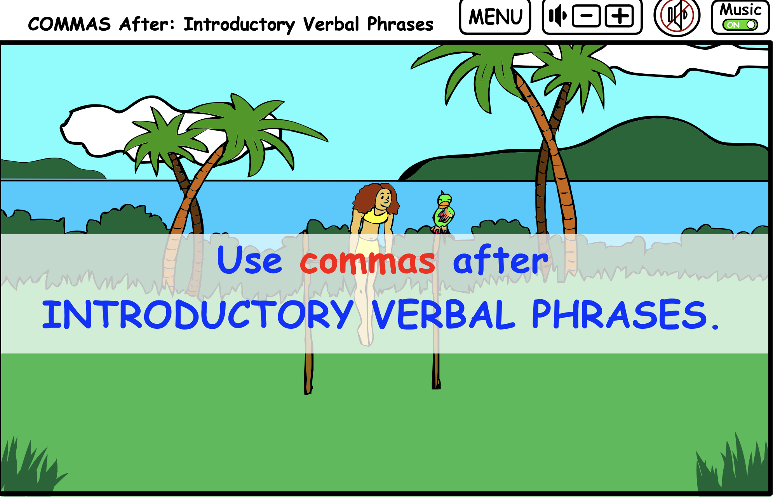

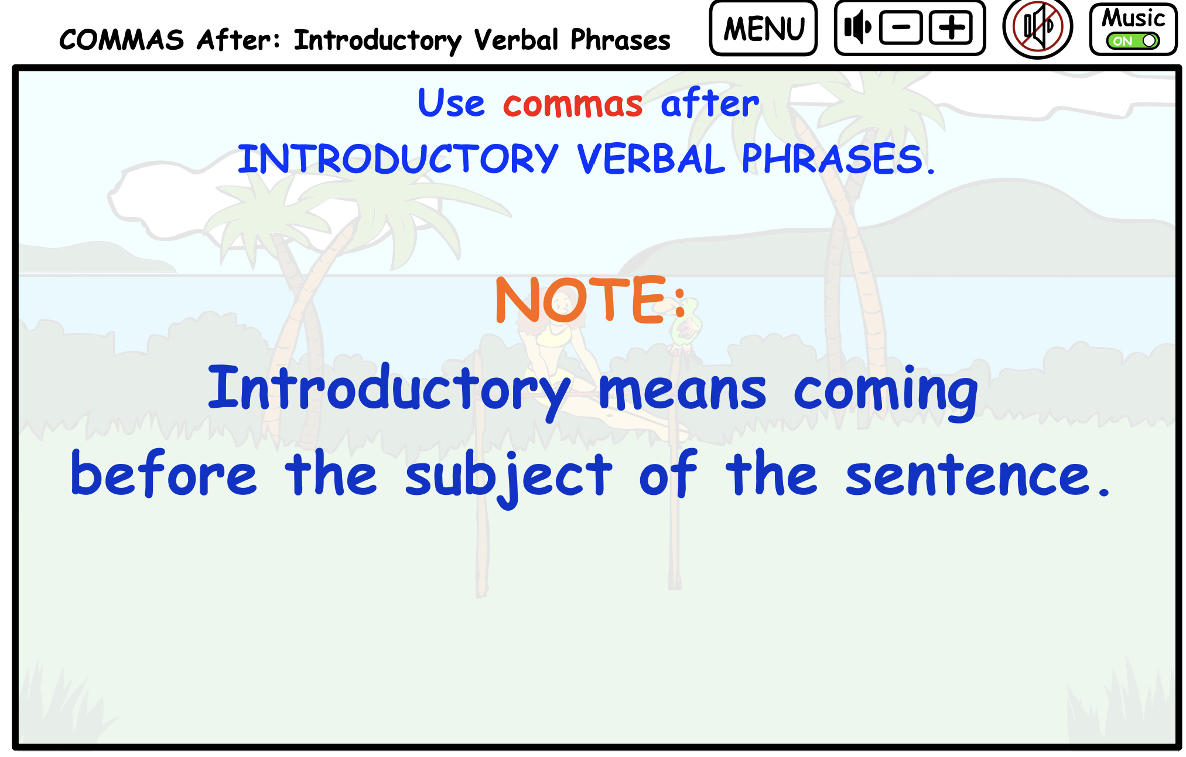

Any time you place a phrase be it a prepositional or verbal phrase
in front of the subject in a sentence, that phrase will generally be set off in commas.

Dancing in the school competition, I learned a lot about controlling my nerves.

Dancing in the school competition is the verbal phrase
that comes before the subject which is I in this sentence.

Notice that the phrase has a comma after it to set it off from the rest of the sentence.

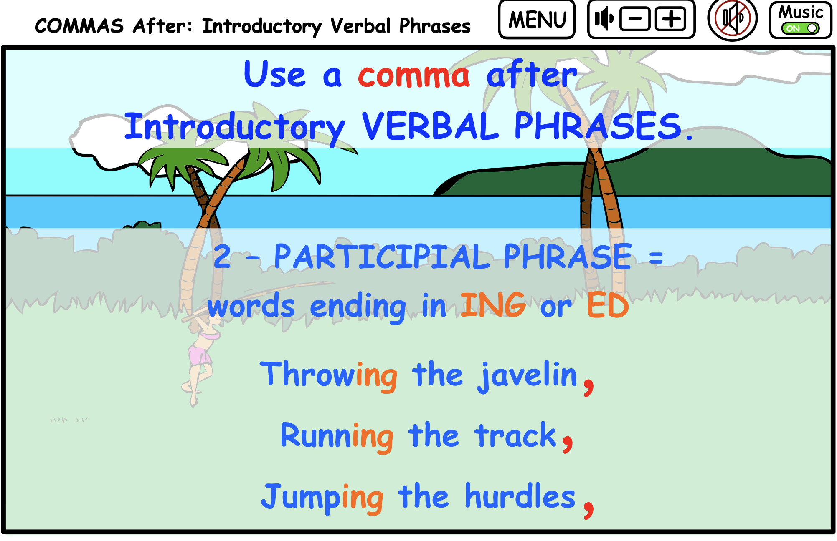
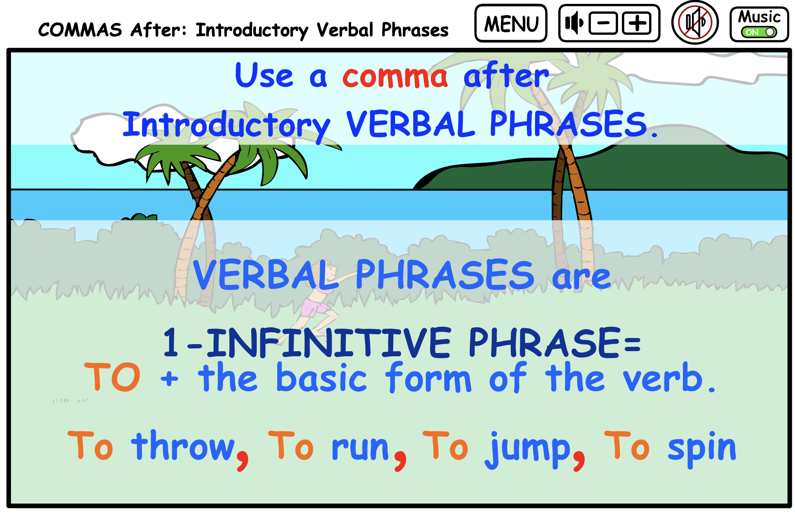

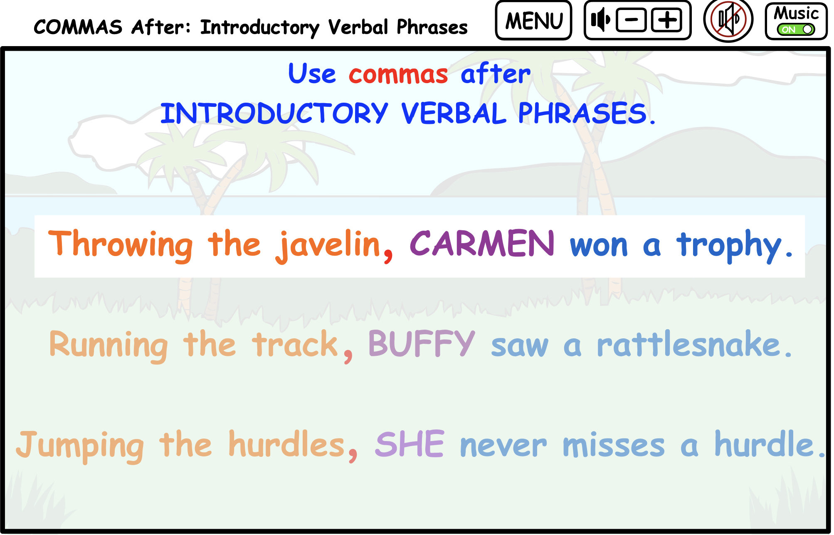

Throwing the javelin, is the introductory verbal phrase,
Carmen is the subject of the sentence.

Running the track, Buffy saw a rattlesnake.

Notice in every case the subject of the sentence needs to be there and follow
the phrase to indicate who is performing the verbal’s action.

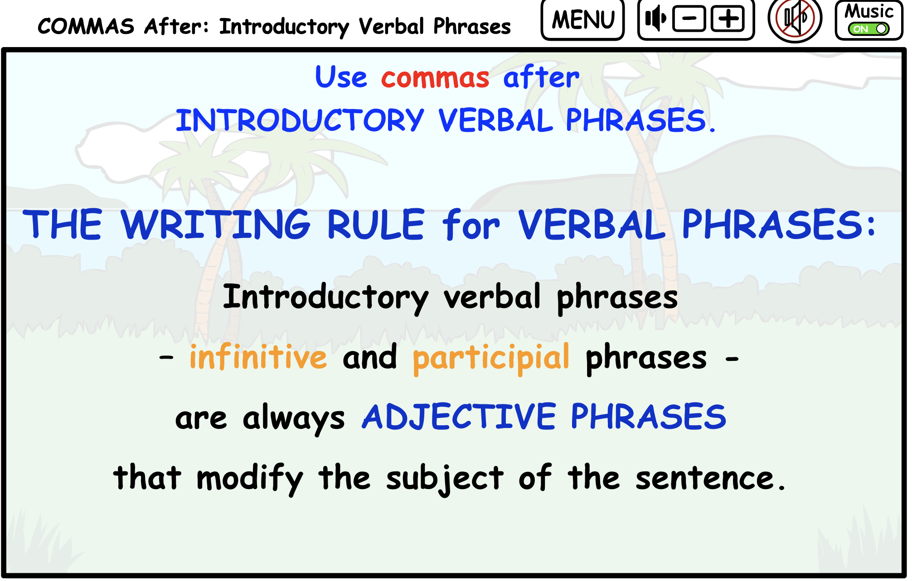

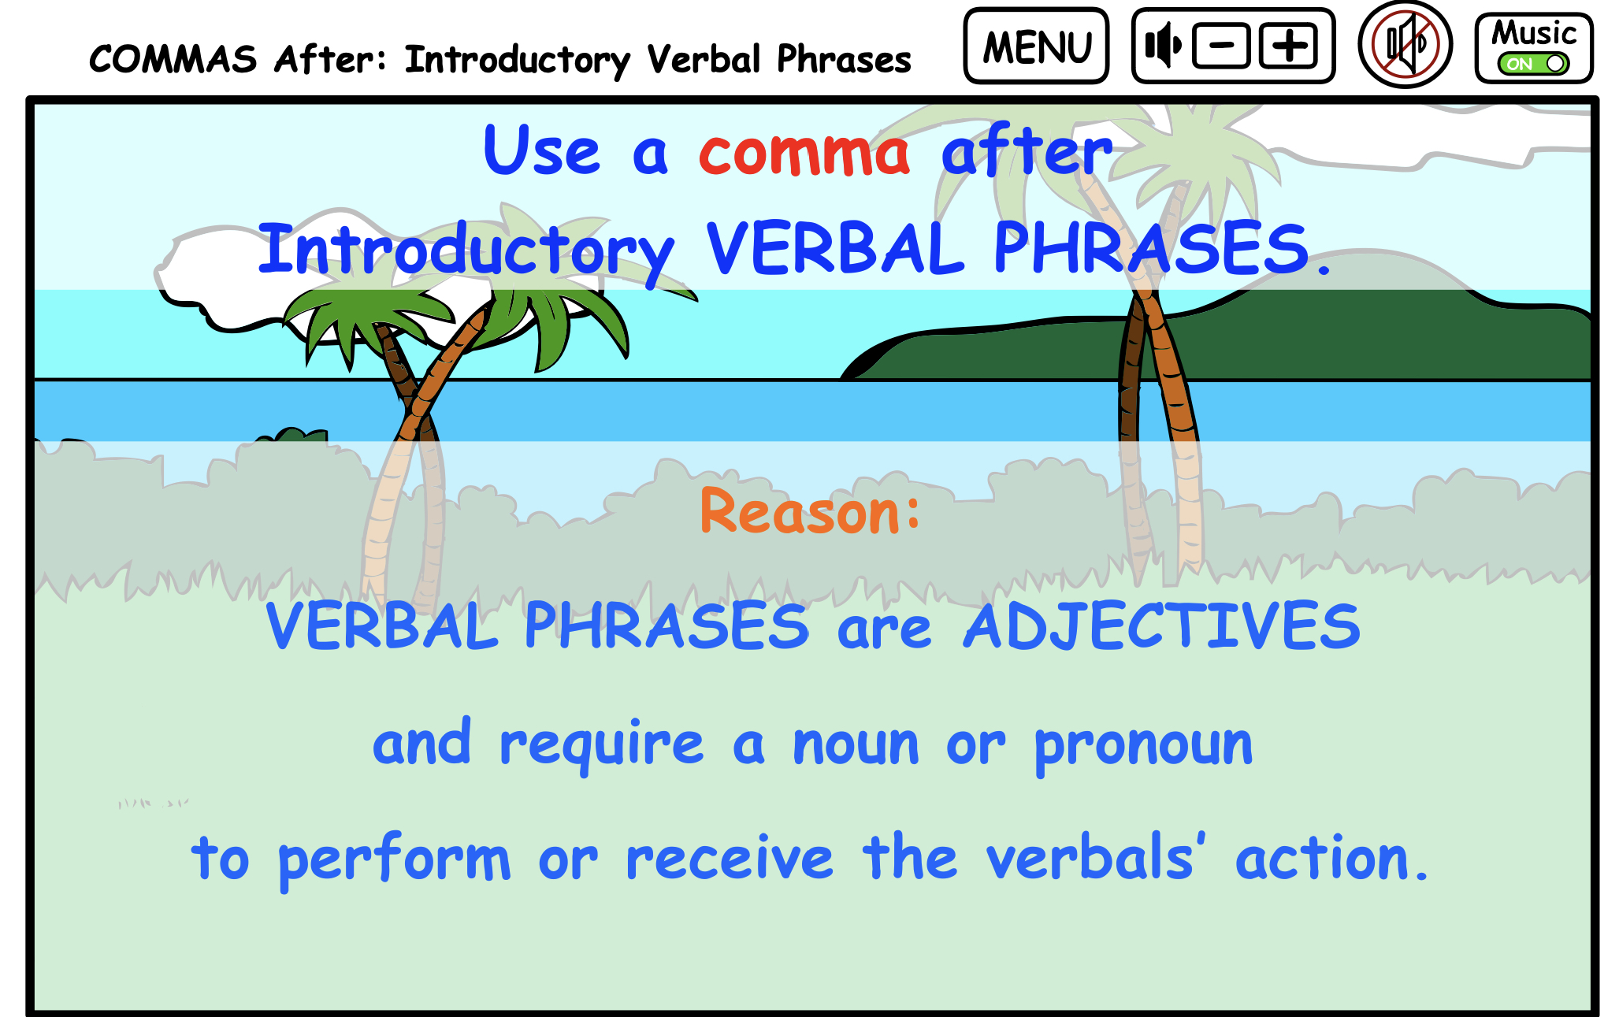

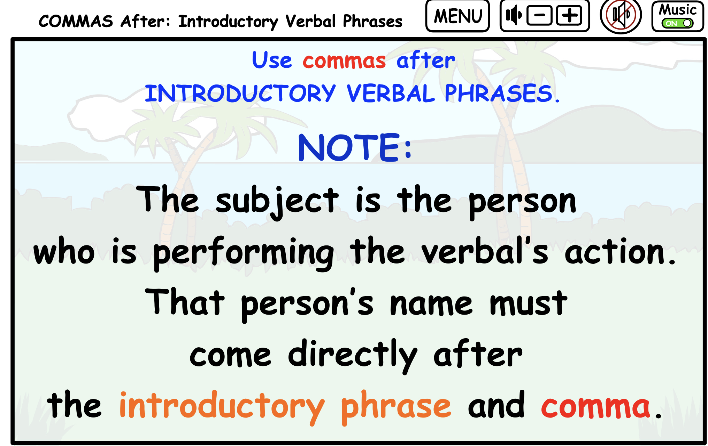

Write 5 or more simple sentences
using one of the verbals like the following: seeing, running, driving, writing, thinking.

Printable Quiz Sentences

DIRECTIONS: Underline the verbal phrase, place the comma where it belongs, and circle the subject of the sentence.

- Selecting a team for the playoffs the coach completed the application.

- Marching in unison the band led the holiday parade down the street.

- Eating all the turkey while the kids were practicing Barf got sick and threw up.

- Camping along the river’s edge we saw moose coming to drink in the river.

- Sneaking quietly up to the nest we could see the eagle feeding its chicks.

ANSWERS: The VERBAL PHRASES and commas are in red and the subject in parenthesis.

- Selecting a team for the playoffs, the (coach) completed the application.

- Marching in unison, the (band) led the holiday parade down the street.

- Eating all the turkey while the kids were practicing, (Barf) got sick and threw up.

- Camping along the river’s edge, (we) saw moose coming to drink in the river.

- Sneaking quietly up to the nest, (we) could see the eagle feeding its chicks.

