**COMMAS AFTER -Introductory Participial Phrases**

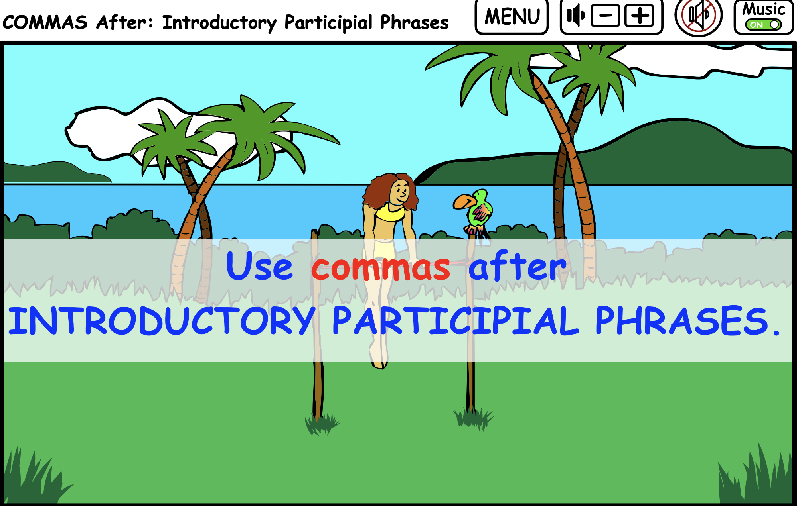

Participles are verb forms that end in -***ING, ED, T, or N-*** used as an adjective.

Running around the track, the team prepared for the meet.

Called for the race, Mick strapped on his track shoes.

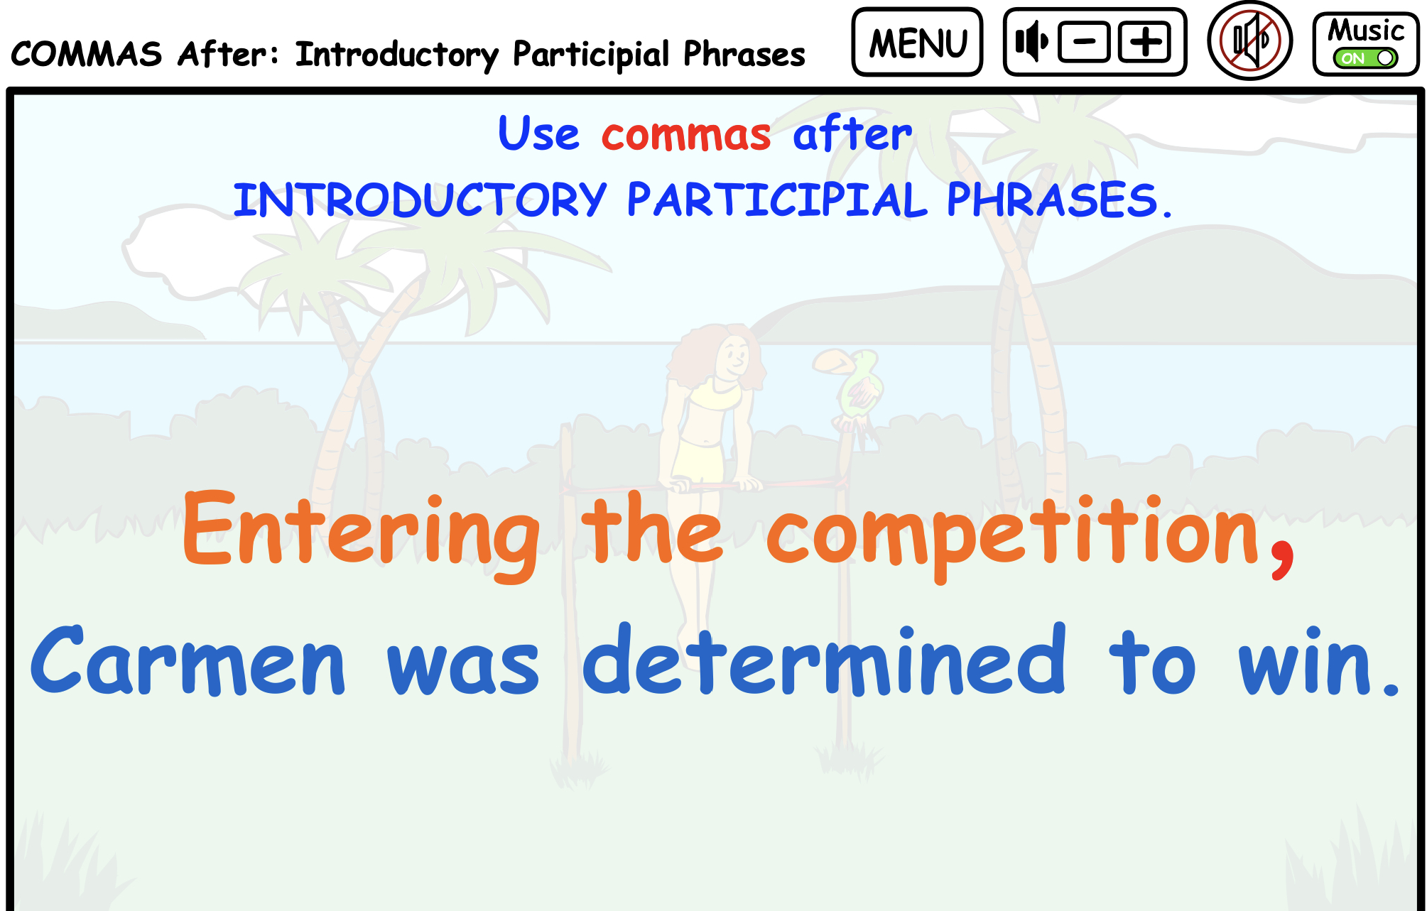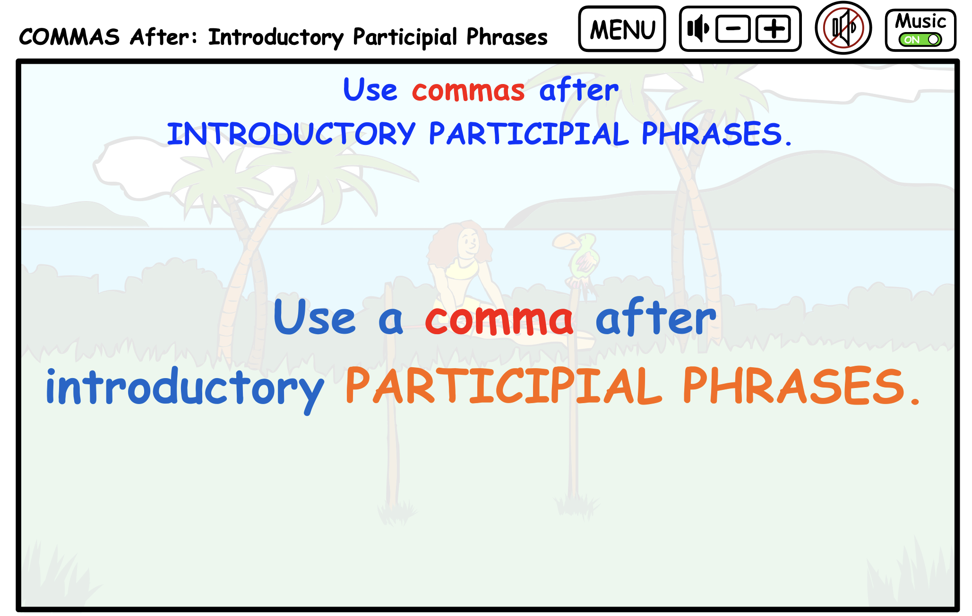

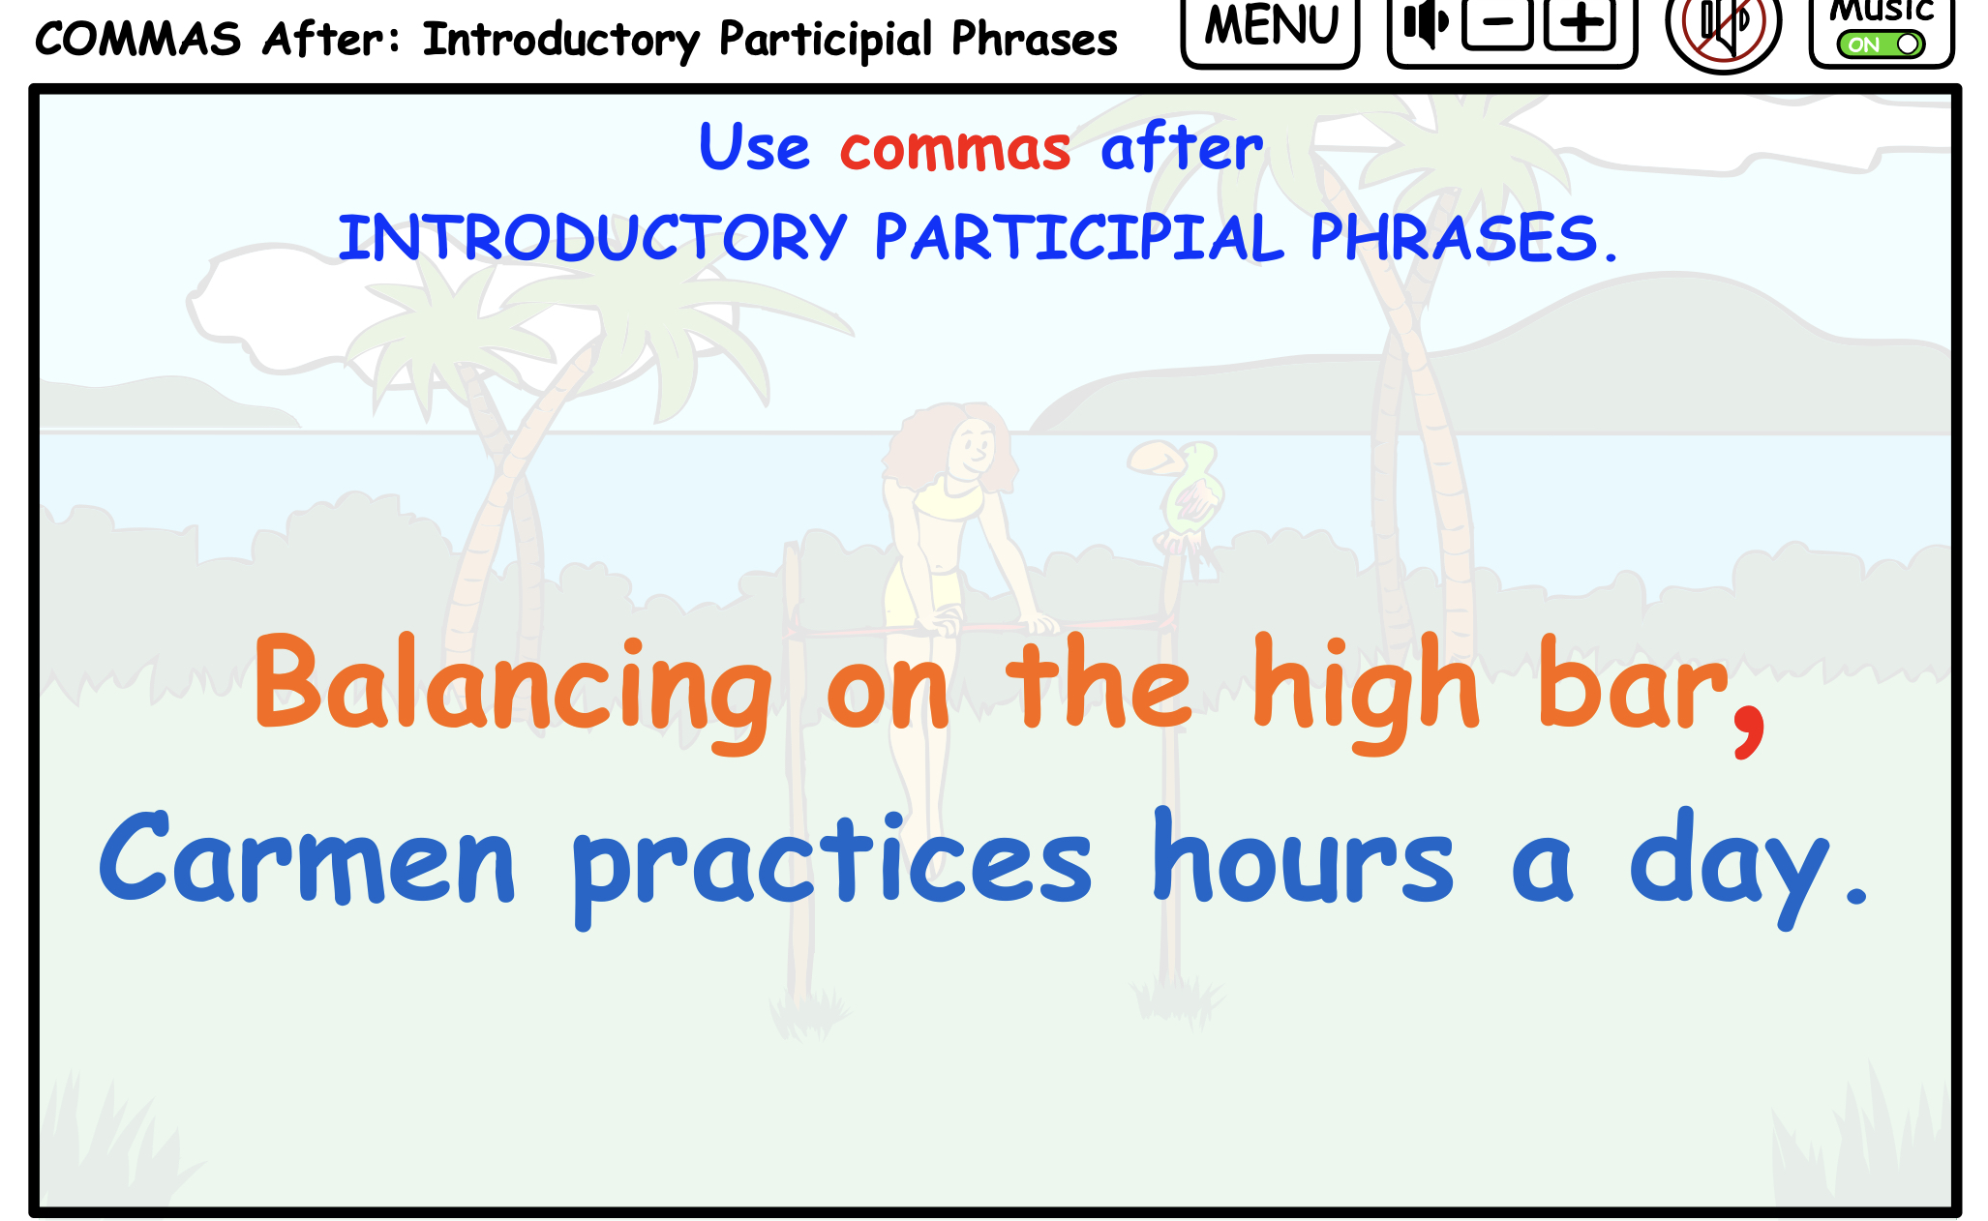

PRINTABLE LESSON PLANS

DIRECTIONS: Underline the Participial Phrase, place the comma before the main sentence, and circle the subject of the sentence.

1. Skating on the edge of the pond I nearly fell through the thin ice.
2. Screaming from fun and laughter the girls ran through the freezing water.
3. Sliding on my knees I got to home plate before the tag.
4. Walking on my tiptoes I could see the panda eating bamboo shoots on the other side of the fence.
5. Dancing on the beach until midnight we celebrated our team victory.

Underline the Participial Phrase and place the comma before the main sentence.

The answers are marked in red.

1. Skating on the edge of the pond, (I) nearly fell through the thin ice.
2. Screaming from fun and laughter, the (girls) ran through the freezing water.
3. Sliding on my knees, (I) got to home plate before the tag.
4. Walking on my tiptoes, (I) could see the panda eating bamboo shoots on the other side of the fence.
5. Dancing on the beach until midnight, (we) celebrated our team victory.